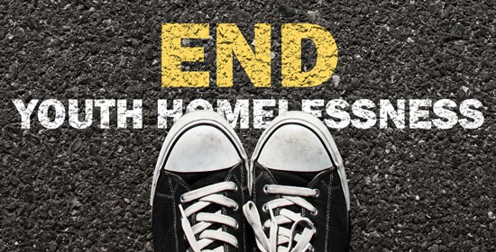
Connecticut Completes First Statewide Homeless and Runaway Youth Count
It is estimated that 500,000 unaccompanied youth will face homelessness this year. Despite that staggering figure, there is lack of community-level data available to drive solutions toward change. In 2015 the Connecticut Coalition to End Homelessness (CCEH) took a huge step and organized the nation’s first ever statewide Homeless and Runaway Youth Count.
Homeless youth are often referred to as the “hidden” population, and capturing information about the true breadth and scope of their experience is made difficult by many factors.
“The way that the shelter system is set up in Connecticut doesn’t do a very good job of capturing youth who are experiencing homelessness,” said Brian Roccapriore, Director of Strategic Analysis at CCEH and the main coordinator for the youth count. “The youth population looks a lot different from the adult population in that [youth] are more likely to be doubled and tripled up, living in hotel, motel situations, staying with friends.”
In order to combat this low-visibility, CCEH facilitated four weeks of youth focused outreach conducted in seven Connecticut cities. The data collected will be used to estimate the number of people under 25 who are experiencing homelessness and unstable living situations.
Willem Donahue, AmeriCorps VISTA with Journey Home, was acting coordinator for the Hartford area.
“We had lots of support from the beginning,” said Donahue, “there was enthusiasm on behalf of the city and the Board of Education. They understood the importance of reaching this population and understanding their needs.”
In Hartford, approximately 2,000 students were surveyed at three public high schools. Another 300 were reached on the streets, in soup kitchens, shelters, and youth programs. The surveys aimed to capture the variety of unstable living situations experienced by youth, and also the services they access or do not have access to. Preliminary results show that 43% of youth surveyed outside of school were found to be experiencing an unstable living situation.
The final youth count report will be available in May, and will be the first standardized tool available to address youth homelessness across the state. In many communities, services for this population are limited or simply do not exist, so the data will be the foundation of Connecticut’s mission to end youth homelessness by 2022.
As HUD Secretary, Julian Castro, stated during his 2015 keynote remarks, “There was a time not too long ago that HUD couldn't tell you how many young adults were living on the streets. We now have a number. We know it's not perfect, but it's getting better, and we appreciate all the work folks are doing to improve it.”
Journey Home would like to thank Hartford Public Schools for their enthusiasm and cooperation, as well as the COMPASS Youth Collaborative Peacebuilders Program for dedicating their knowledgeable staff to the outreach effort.

