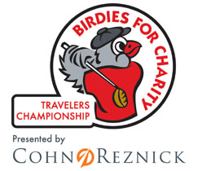
Journey Home Now Accepting Donations for Birdies for Charity Fundraiser

Since 2004 the Birdies for Charity fundraiser has been a staple of the Travelers Championship and an exciting opportunity for every non-profit in the Northeastern United States. Last year the championship raised $1.56 million for some 140 charities.
Similar to a walk-a-thon, donors pledge a small amount for each birdie made during the six-day tournament. For example, a 10-cent pledge with 1,500 birdies made will raise a total of $150. With the 1,828 birdies made at last year’s championship, $22,000 was raised for Journey Home. This impressive sum also earned us a booth in the “Fan Zone”, and the opportunity to raise awareness among the event’s 50,000 attendees.
“There is great energy that comes with this particular fundraiser,” said Matt Morgan, Executive Director of Journey Home, “we compete to get the most pledges, but really, everyone wins.”
In 2015 we are striving to surpass last year’s record breaking total. The pledges we receive will help ensure that we meet our goal of ending chronic homelessness in Greater Hartford by 2016. If you support this mission we ask that you please visit Journey Home’s pledge submission form link below.
Thanks to Travelers Championship, Cohn Reznick, Connecticut Association of Nonprofits, Ford and other generous sponsors, Journey Home is afforded this amazing opportunity every year. Catch all the action June 22-28th at the TPC River Highlands in Cromwell. We’ll see you in the Fan Zone!
Pledge Link: https://events.r2it.com/birdies/DefaultPage/TravelersChampionship/Default.aspx?site=travelerschampionship&siteId=85&charity=JourneyHomeInc&charityId=104134

