LEGO Summer Camps for the Serious Builder
Bippity Bricks 2453 72nd Avenue SE, Mercer Island, WA 98040 206-232-5147 alice@bippitybricks.com
Dragons, Elves, and Wizards

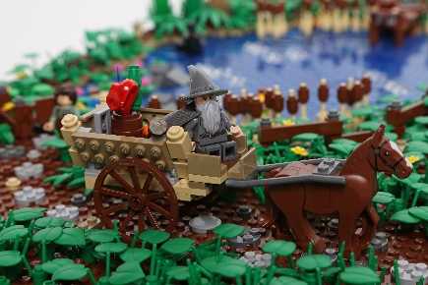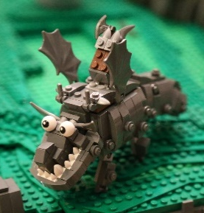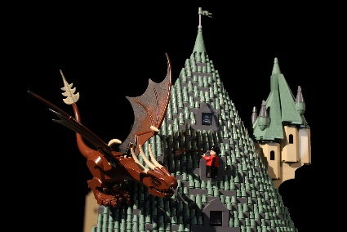

This camp will develop a landscape and scenes based on the general theme of Medieval Fantasy. Participants will learn building techniques throughout the week and apply them to planning and building their own landscape section and scene that will be part of a larger collaborative project. Together they will plot out a story, the scenery, props, and characters, and then take on individual sections to build (and take home). On Friday, they will learn the basics of stop motion animation and film a short section to tell the adventure they develop and play out using the models they have created. Participants will need to bring an ipad with the free app, LEGO Movie Maker installed. This camp is great for kids who enjoy building a variety of kits, want to explore how to do more interesting free building, and get ideas for how to play with what they’ve built.
Session 1 June 29-July 3  9 am to noon  10 children per session  Ages 8 to 14 | $375  This includes $75 worth of brick from daily small technique builds, a 32x32 baseplate, and approximately 500+ bricks used to build their portion of a detailed landscape and scene.
Personalized Modular Building
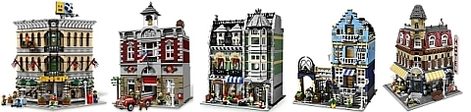

A class intended for advanced builders interested in learning how to design and build their own modular building. We will look at how real architectural details can be recreated, different styles of architecture appropriate for a modular design, how to build using standards established in the theme, and the importance of planning and interior design to making for a complete design. With over 1 million bricks in my stash, participants will be able to choose from a palette of color options, interior details, exterior styles, and design a unique building that they can add to their modular lineup. This camp is great for builders who enjoy building challenging models and are ready to take their skills and apply them to building their own highly detailed architectural model.
Session 2 August 24-28  9 am to noon  10 children per session  Ages 8 to 14 | $500  This includes $200 worth of brick from daily small technique builds, a 32x32 baseplate, and approximately 2,000+ bricks to build a highly detailed, personalized, 3 story modular building.
Building Techniques
A sampling of advanced techniques to develop building skills (both camps)
- Telling a story- plan out your setting, action, characters, and features
- Scale- Microscale, minifig scale
- Sculpture- modeling everyday objects
- Color palette
- Directional building- sideways and inverted building
- Texture and details
- Things that move- hinges, turntables, angles
- Setting the scene- building a varied and interesting landscape
Registration and Cancellation Policy
- Spots are filled on a first come first serve basis. If interested, please send the following information to alice@bippitybricks.com
  - Child’s Name
  - Experience level
  - Age
  - Session requested
  - Parent name(s)
  - Parent cell phone
  - Parent email
  - Favorite set that they have built (and why)
  - Thing/place/scene that someday they would like to build out of LEGO
  - If registering for the modular session, please list a few ideas of what you would like your building to be
- Upon confirmation of acceptance, please send payment to above address
- Camps will be held in my home on Mercer Island.
- Cancellation up to 30 days prior to the first day of class will receive a refund of $300 (tuition, excluding the materials fee)
- Cancellation after that will receive a refund of $100
Who is Alice Finch?
- Active volunteer and Art Enrichment Chair at West Mercer Elementary
- Credentialed and award winning educator with experience teaching both children and adults
- Award winning and internationally recognized builder. See more of my work at https://www.flickr.com/photos/88574960@N02/sets
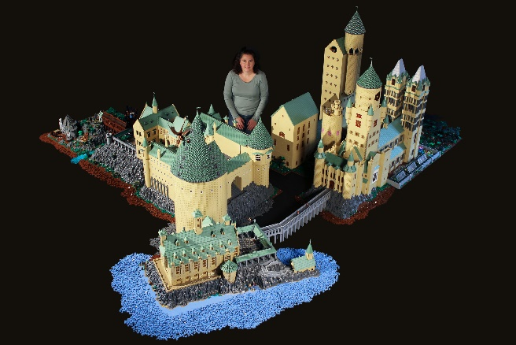 |  | 