Bippity Bricks LEGO Club - Winter

Tuesdays  3:30 to 5:30  West Mercer Library | Grades 1-5 | Winter Session - 10 classes  January 12, 19, 26  February 2,9,23 (no school on the 16th)  March 1, 8, 15, 22 | $250 + $50 for materials  technique builds are brought home throughout the session

This after school program is open to girls and boys who like to build and who want to build better. STEM topics like simple machines will be combined with building techniques like plate built lettering and building in the round to make for interesting and engaging building experiences. Small technique builds are meant to be brought home to help kids remember the techniques they learned in class and apply it to their own creations.

Sample Projects
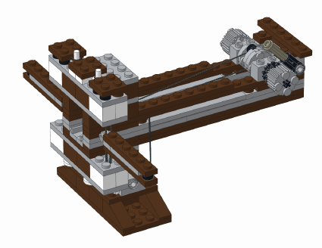  Ballista | 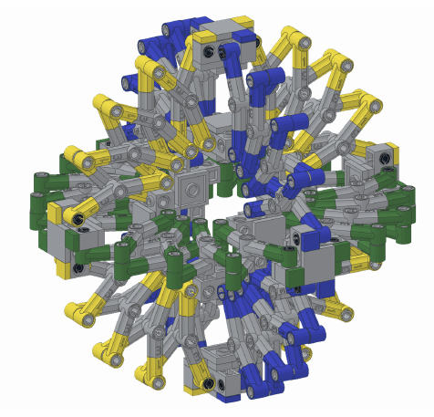  Expanding Hoberman Sphere | 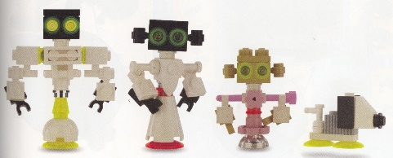  Robot Family
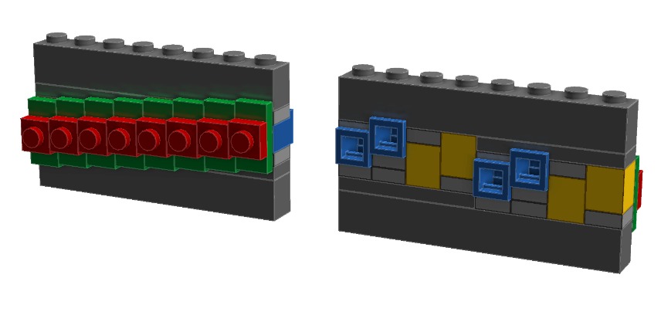  Graduated stud placement | 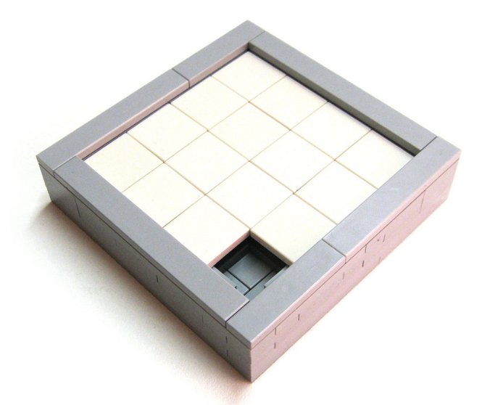  Sliding Puzzle | 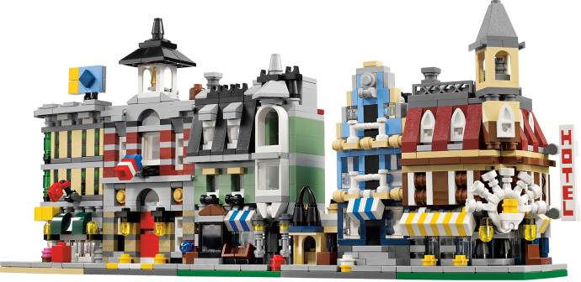  Microscale
  Facial expressions | 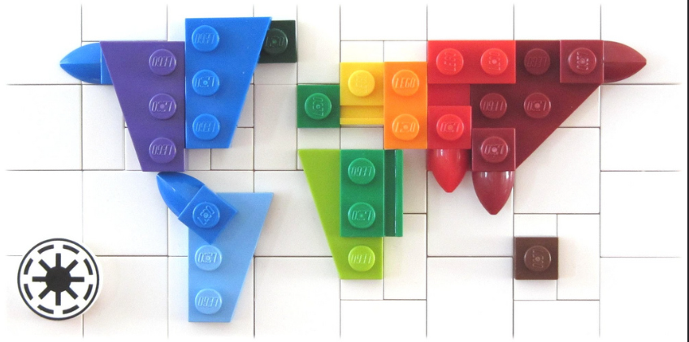  World map | 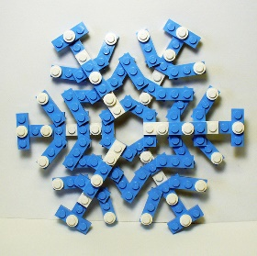  Snowflakes

Registration
Please send information and payment to Alice Finch, 2453 72nd Avenue SE, Mercer Island WA 98040
Information can also be sent to alice@bippitybricks.com
Child Name(s) | Grade and Teacher(s)
Parent Name(s) | Parent Cell phone(s)
Parent email

Emergency Contact (local, but not parents) | Emergency Contact phone

