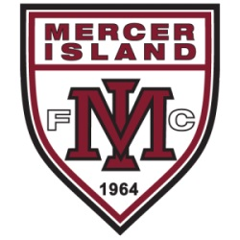 | Mercer Island FC Hosts Sounders Women at MIHS Saturday July 11th 3pm@MIHS Stadium | 

Mercer Island FC is proud to host the Sounders Women in their W-League match against the Arizona Strikers FC on Saturday, July 11th, 3:00pm at MIHS Stadium. The W-League is the Pro-Am League for Women in the United States, just below the National Women’s Soccer League the Seattle Reign compete in. The City of Mercer Island has recognized the match as an official event of the Mercer Island Summer Celebration.

Activities include –
- Pre-game Clinic with Sounders Women players and Coaches before the match from 1-2pm - $25 for MIFC players - $50 for all others. Open to girls and boys ages 6-18. Space is limited, register at http://swclinicjuly11th.eventzilla.net
- Two MIFC teams will be selected to march in with the women from the Sounders and Strikers and serve as ball girls around the field during the match
- The MIFC Girls team that sells the most tickets get a training session with players from the Sounders Women team
- The MIFC Boys team that sells the most tickets get a training session with Sounders U23 team members
- Fun half-time activities for players.
- Sounders Women and MIFC Merchandise will be available for purchase during the match.
- Food trucks will be on-site with a variety of options

In order for your team to qualify for the special team training sessions with the players, you need to enter your team “code” when purchasing tickets on-line. Your team code is MIFC + your team year. For example –
- MIFCB04A
- MIFCB01B
- MIFCG99A
- MIFCG02B

To qualify to win the team training session, tickets must be purchased in advance at http://www.sounderswomen.com

