
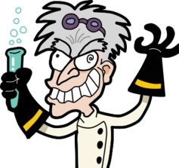
Chemistry is a BLAST!
Who
Incoming 6th, 7th and 8th graders who have a GPA of 3.0 or higher

Where & When
Monday – Friday
August 10th – 14th, 2015
8 a.m. – Noon

Newport High School
Room 3114
How to Register
Go to http://www.chemistryisablast.com/
Cost: $249 (includes t-shirt & equipment fee)
(There will be no extra charge for any breakage of glassware/equipment)
There are only 30 slots available, so sign up ASAP!
Questions?
Email: Chemisablast@gmail.com
About the Instructor
Melissa Baker has taught high school chemistry for 8 years. She has a master’s degree in science education and a passion for inspiring a love and appreciation for science in all of her students.

“Disclaimer: Mercer Island School District has neither reviewed nor approved the program, personnel, activities or organizations announced in this flyer. The participants agree to protect, indemnify, and hold harmless the district, its elected and appointed officials, employees, agents, staff and volunteers, from any and all claims, liabilities, damages, expenses, or rights of action, directly or indirectly attributed to the activities. Permission to distribute this flyer should not be considered a recommendation of the program by the school district. This is not a school district sponsored activity.”

Learn the Chemistry
Behind…
- Fire!
- Tie dye!
- Color changing reactions!
- Ice cream making!
- Gak!
Chemistry is a BLAST is a week-long camp that will give students with an interest in science a chance to get hands-on experience with lab equipment and learn basic chemistry!
Summer Science Camp

