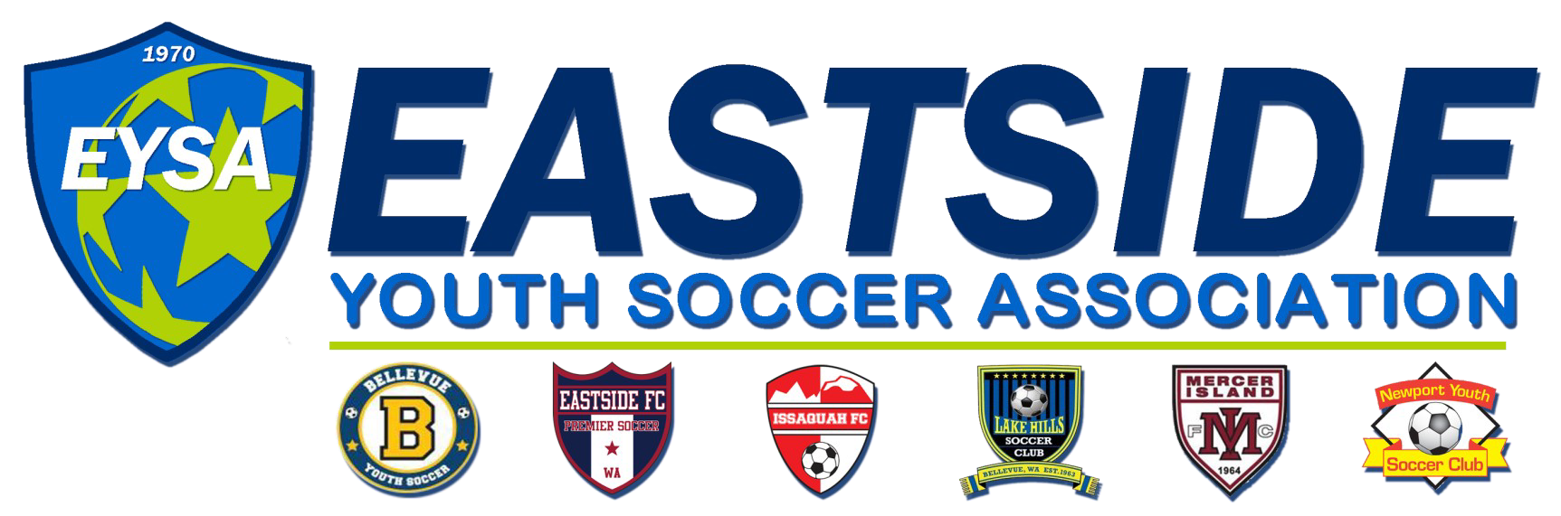

2016 Spring Soccer Academy is Here!

Mercer Island FC and our sister clubs in the Eastside Youth Soccer Association are excited to once again offer our Spring Soccer Academy and Get Ready for Select training clinics. This is one of our longest running and most popular programs. Don’t delay, this program fills up quickly!

The clinics are designed for soccer players of all levels. They will prepare the player trying out for Select or Premier by focusing on skills that will be important in the upcoming tryouts and on improving individual skills. The camp will provide Recreational players the opportunity to polish and renew skills they are ready for fall soccer.

Academy Details:

- AGE GROUPS - U6 thru U14 (Free T-Shirt included)
- TIMING - Clinics will begin Monday March 14th. There will be 6 weeks at each location (off during spring break, so duration is 7 weeks).
- WHERE - Mercer Island, Bellevue and Issaquah locations:
  - Issaquah: Mondays 5:30 - 7:00 pm, Wednesdays 6:00 - 7:30 pm, and Saturdays 2:00 - 3:30 pm at Issaquah Highlands
  - Bellevue: Tuesdays 4:00 - 5:30 pm, Thursdays 4:00 - 5:30 pm, and Saturdays 11:00 am - 12:30 pm) at Newport Hills
  - Mercer Island: Tuesdays 6:00 - 7:30 pm, Wednesdays 3:00 - 4:30 pm, and Thursdays 6:00 - 7:30 pm at Islander Middle School
- COST -$175/player

Academy Goals:

U6-U9: Ball mastery and dribbling - 1v1 core, ball control, receiving/trapping/juggling, passing technique/pace/rondos, scrimmaging/games, FUN!
U10/U11: Intermediate ball mastery and dribbling - 1v1 core/away pressure, intermediate ball control - juggling tricks/improvement, intermediate passing – triangle/away pressure, positioning – support/shape/space, defending - basic.

U12+: Advanced ball mastery and dribbling - advanced ball control – receiving/turning away/pressure/shielding/possession, advanced passing – pace/away, pressure/rondos, advanced defending – support/cover.

Register by going to www.EYSA.org
The link to register will be on the lower left hand side

