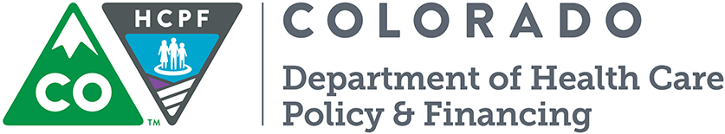
County Incentive Program

Collaboration Incentive
  - SFY 2015-16

County Contact Info:

County: Choose Your County

County Contact(s): Click here to enter text.

Email: Click here to enter text.

Phone: Click here to enter text.

Goals:
Please list the 2-3 goals the county and the partner attendees would like to accomplish over the next year to improve clients’ access to care:

1. Enter Goal 1

2. Enter Goal 2

3. Enter Goal 3

Department Contacts:
Joshua Montoya and Crestina Martinez
HCPFCountyRelations@state.co.us
303-866-2403 / 303-563-9109 cell

Select Quarter: Select a Quarter

Meeting Date(s): Enter Meeting Date

Supporting Attachments (please check all that apply):
☐Agenda | ☐Minutes
☐Sign-in Sheet | ☐Other: Please Describe

Partner Attendees (please check all that apply):
☐Behavioral Health Organization (BHO) | ☐Regional Collaborative Care Organization (RCCO)
☐Local Public Health Agency (LPHA) | ☐Medical Assistance (MA) Site
☐Connect for Health Colorado (C4HCO) | ☐Hospital/Clinic serving County
☐Federally Qualified Health Center (FQHC) serving County | ☐Private Practice Providers serving County
☐Community Mental Health Centers serving County | ☐Long-Term Care Facilities serving County
☐Single Entry Point (SEP) Agency serving County | ☐Other: Please Describe
☐County Sheriff/Local Law Enforcement serving County | Additional Info:  Enter Any Additional Information Here

