**MISSION**

*“Provide outreach to homeless veterans and Veterans pending homelessness that are in need of VAMC services and resources that include prevention and rapid re-housing funds and long te****r****m housing in assisting those veterans to attain or maintain their highest level of independent living.”*

The Community Resource & Referral Center (CRRC) provides “one-stop shopping” for homeless Veterans.  The CRRCs *low-threshold to entry* is an essential element to improving access in engaging Veterans, including female veterans and their families as the *critical first step* to obtaining needed services.  CRRC is a critical piece of PVAHCS strategy to achieve the Secretary’s Five Year Plan to End Homelessness among Veterans by:

* Increasing access
* Creating an environment for integrated service delivery

This functioning service hub assists Veterans who are homeless or in otherwise untenable housing situations, moves homeless Veterans rapidly into stable housing, provides homeless prevention services and ensures a continuous community based service for our Veteran housing needs.

The CRRC Team comprised of Peers Supports, an Addiction Therapist,  Social Workers, Employment Specialists, Administrative Assistant, and an entire team dedicated to medical care “ Homeless Patient Aligned Care Team”.  We are located at 1500 E Thomas Rd Suite 106 Phoenix, AZ (entrance on the backside of the building). What makes us unique…we are purely walk-in based with no appointments necessary.

Our CRRC team conducts outreach to 45 different agencies or areas each week to include:

* Jail Outreach
* Street Outreach combing canals, bridges, fields, and abandoned buildings
* College Campuses
* Libraries
* Bus Stations
* East Valley (Apache Junction, San Tan Valley, Gilbert, Chandler, Mesa, Tempe)
* West & North Valley (Glendale, Sunnyslope, Avondale, Peoria, and Surprise)
* Bicycle outreach into parks throughout Central Phoenix and Tempe
* Light Rail outreach in Phoenix, Tempe, and Mesa
* Network with local ERs, Police Department, Fire Department,  Halfway Houses, Shelters, Heat Respites  and Hydration Stations
* Manage National Homeless Hotline
* Domestic Violence Shelters
* Senior Resources (to include housing & day centers)
* Outreach to internal stakeholders at PVAHCS
* Vet Centers
* Department of Economic Services
* Social Security
* Community Events ( Project Connect, O’Odham Celebration, Phoenix Pride, Welcome Home Event, etc)
* Stand Down (provided outreach to 1759 veterans in the 2-day event)
* VA2K Walk & Roll Water Drive
* Cold Calls from the Community identifying a homeless veteran’s location & dispatching a team to provide outreach

The CRRC also has a point of contact for each special population to include: Women, OEF/OIF/OND, Native, LGBT, and Seniors with goal to continue to collaborate and develop resources for them.

Co-located at the CRRC is our Homeless Patient Aligned Care Team (HPACT) who is comprised of a Nurse Practitioner, Registered Nurse, Licensed Practical Nurse, Social Worker, and Medical Support Assistant.  This team provides walk-in ambulatory care services for those veterans who are homeless and unassigned to a provider at PVAHCS.  This team provides walk-in services to the veteran with no appointment necessary and is a wonderful compliment to the CRRC.

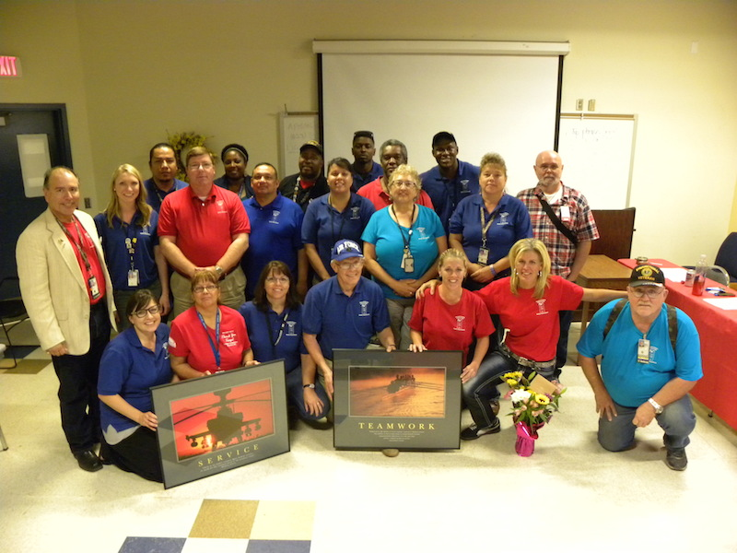

|  |  |
| --- | --- |
|  |  |
|  |  |
|  |  |
|  |  |
|  |  |
|  |  |
|  |  |
|  |  |
|  |  |
|  |  |

**Community Resource & Referral Center (CRRC) for ALL Homeless Veterans**

                    “*Veteran Services*” Office in the Lodestar Day Resource Center

                           1125 W Jackson Phoenix, AZ 85007

                        602-463-2432 or  602-568-7843

**24/7 Homeless Call Center**  1-877-424-3838

              Monday-Thursday 7:30am to 5pm  and Friday 7:30am to 4pm

**Walk-ins only**

* Order DD-214
* Eligibility Verification & Registration
* Limited in-kind benefits (to include clothing & hygiene kit)
* Access to Healthcare (medical, mental health, &  substance abuse)
* Transitional Housing with opportunity for dental services
* Coordination with community resources to include Permanent Housing
* Bicycle Program
* **Daily** Shuttle to/from VA                     7:30a-2p
* **Daily** Eligibility & Registration:          HPACT MSA/Eligiblity Specialist
* **Daily** Outreach & Assessment:           CRRC VA social worker
* **Daily** Peer Support Services:              CRRC Peer Supports
* **Daily** Employment Services:               CRRC Employment
* **Daily** Medical Care:                          Homeless Patient Aligned Care Team
* **Daily** Substance Abuse Services :       CRRC Addiction Therapist
* Every *Tuesday* & *Thursday* 8a-Noon:  VASH Information & Referral
* Every *Wednesday* 9a-4p:                     VA Regional Office

*“Veterans one-stop shop for healthcare, housing, and hope”*

Light Rail 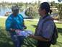ParksBicycle