STOP
TOBACCO CESSATION PROGRAM
2015

Are you interested in quitting smoking or chewing? The Phoenix Indian Medical Center (PIMC) Public Health Education and Pharmacy Tobacco Clinic would like to encourage you to consider using our 2015 Tobacco Cessation – STOP Program. STOP classes are offered every month. If interested, please call PIMC Public Health Education at 602-248-4195 to schedule an appointment or to discuss your options. Schedule now includes Yavapai Apache Nation Tobacco Cessation clinic days on the 1st Tuesday of every month.
***Excluding Federal Holidays***

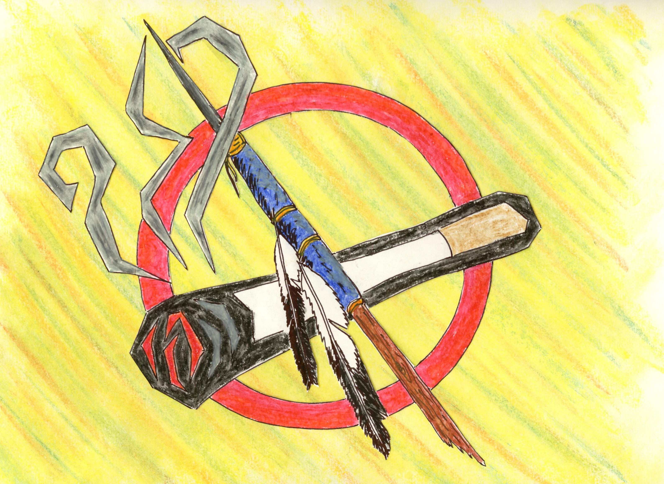  Every Wednesday – Pharmacy Tobacco Clinic Only  Every Thursday – Pharmacy/Health Education STOP  9:00 am – 4:00 pm |  | Yavapai Apache Nation  Tobacco Cessation Clinic  PIMC Pharmacy/Health Ed.  10:00 am – 3:00 pm
Every Wednesday  Specialty Clinic | Every Thursday  Specialty Clinic | 1st Tuesday of month  Yavapai Apache Health Center
February 11, 18 & 25, 2015  March 4, 11, 18 & 19, 2015  April 1, 8, 15, 22 & 29, 2015  May 6, 13, 20 & 27, 2015  June 3, 10, 17 & 24, 2015  July 1, 9, 15, 22 & 29, 2015  August 5, 12, 19 & 26, 2015  September 2, 9, 16, 23 & 30, 2015  October 7, 14, 21 & 28, 2015  November 4, 11, 18 & 25, 2015  December 2, 16, 23 & 30, 2015 | February 12, 19 & 26, 2015  March 5, 12, 19 & 26, 2015  April 2, 9, 16, 23 & 30, 2015  May 7, 14, 21 & 28, 2015  June 4, 11, 18 & 25, 2015  July 2, 9, 16, 23 & 30, 2015  August 6, 13, 20 & 27, 2015  Sept. 3, 10, 17 & 24, 2015  Oct. 1, 8, 15, 22 & 29, 2015  November 5, 12 & 19, 2015  December 3 & 17, 2015 | March 3, 2015  April 7, 2015  May 5, 2015  June 2, 2015  July 7, 2015  August 4, 2015  September 8, 2015  October 6, 2015  November 3, 2015  December 1, 2015

NOTE: Evening group sessions will be provided on a trial basis on March 12th and April 9th, 2015 from 4:30 – 6:30. These sessions will be held at the Aztec Building, Suite 375W,

1616 East Indian School Road, Phoenix, Az 85016.
Individual Sessions
If the schedule above does not meet your present needs, we invite you to schedule an appointment for an individual session by calling:
- PIMC Public Health Education at (602) 248-4195

For Additional Resources contact:
- ASHLINE at (800) 556-6222
- Tobacco Cessation Acupuncture, PIMC Specialty Clinic, 602-263-1200 ext. 1514

Medication
Nicotine patches and Zyban tablets are available through PIMC Pharmacy to assist cigarette smokers and smokeless tobacco users to quit. You must be eligible to receive care at PIMC.
Revised 01-06-15

