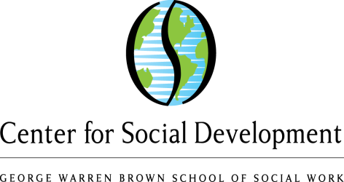
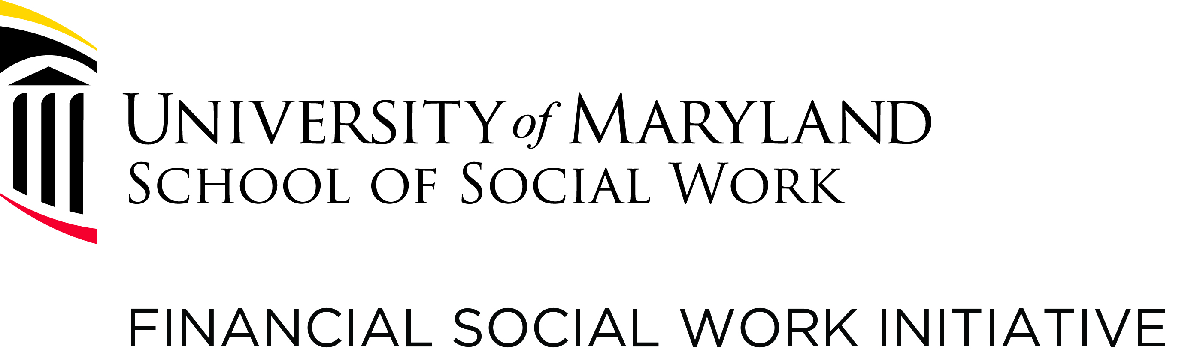

A Second Convening on
Financial Capability and Asset Building (FCAB): MOVING FORWARD
To Be Held As the SSWR 2016 Annual Conference Begins
To Be Held Near the Conference Hotel at the
Council for Advancement and Support of Education (CASE)
1307 New York Ave NW, Suite 1000
Washington, DC 20005-4701

January 14, 2016, 8:00 a.m. (registration begins at 7:30 a.m.) to 1:00 p.m. (dinner for all the night before on January 13, 2016)

Please join FCAB scholars, educators, and researchers in a special one-day free forum and hear policy and funding experts discuss issues related to financial education, coaching, stability, and empowerment. Hear and learn about:
- funding and research opportunities and the latest policy initiatives
- measurement and surveys for financial coaching
- consumer protection for vulnerable clients, families, and communities
- impact of financial education on social work practice, education, and research
- plans to connect to Grand Challenges (to be announced during SSWR conference), specifically “financial capability and asset building for all” working paper ideas
- working groups and connections within FCAB for ongoing research and collaboration
- fostering further cohesion for researchers, scholars, and educators
GUEST SPEAKERS
Daniel Dodd-Ramirez, MA
Assistant Director of Financial Empowerment/Consumer Education and Engagement Division
Consumer Financial Protection Bureau. Mr. Dodd-Ramirez is a former executive director, community organizer, and human resources director. He will discuss:
- New, emerging areas in CFPB
- Role of social services and social work
- How can social work research can inform CFPB’s work

Louisa Quittman, MPA
Director of the Office of Financial Education, U.S. Department of the Treasury. Ms. Quittman plays a lead role coordinating the interagency Financial Literacy and Education Commission (FLEC) and supports the President’s Advisory Council on Financial Capability, mymoney.gov website, and the National Financial Capability Challenge. In prior work, she focused on financial access in traditionally underserved communities. She will discuss:
- Funding and the role of social work research
- Promotion of financial education in financially vulnerable households and communities

J. Michael Collins, PhD
Director of the Center for Financial Security/University of Wisconsin, Madison, and Associate Professor at the La Follette School of Public Affairs and at the School of Human Ecology. Dr. Collins studies consumer decision-making, financial capability in low-income families, and is a leading voice on financial coaching. His new book is A Fragile Balance: Emergency Savings and Liquid Resources for Low-Income Consumers. He will discuss:
- Measurement/funding/conceptualization in financial capability and financial coaching
- Providing guidance to social workers on our research and shared interests

Register at http://www.eventbrite.com/e/fcab-convening-2-moving-forward-tickets-19072496350
Please contact Christine Callahan, PhD, LCSW-C, Research Assistant Professor at the University of Maryland School of Social Work/Financial Social Work Initiative, at ccallahan@ssw.umaryland.edu for more information. CEUs offered!

