7th Grade Camp Trip Fundraiser
(All proceeds go toward funding the 7th Grade Camp Trip in November 2015)
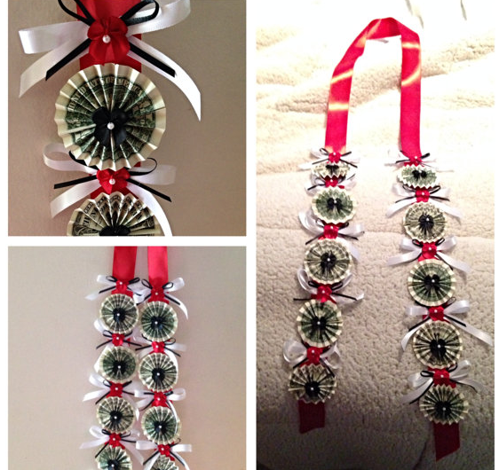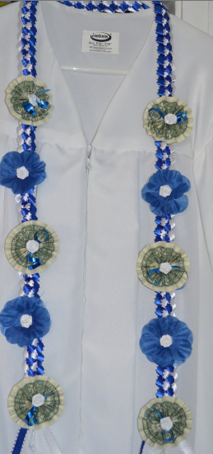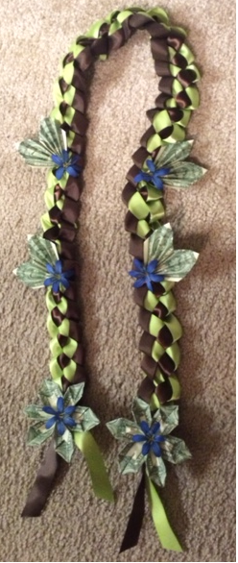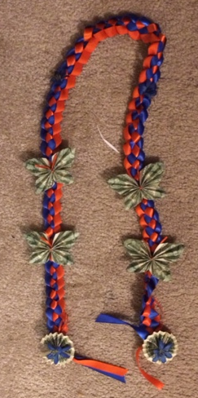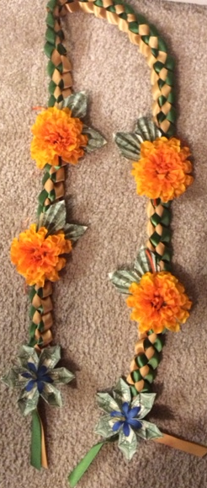
Design #1 Design #2 Design #3 Design #4 Design #5

Graduation Money Lei - $35.00 each
Handmade money leis for your special graduate! Price includes the $10.00 worth ($1.00 bill denomination) on the money lei.
If parents would like to personalize their own money lei, you can do so by contacting the parents below.
Good for Preschool, Kindergarten, 6th Grade, High School, and College Graduates!
Made to order to match your graduate’s school colors.
To order please contact: Mary Antonio @510-303-4183, Lili Harrell @925-580-6561, or Jenn Bernaldo @510-384-0694
or return the portion below with money to 6th Grade Homeroom or to the Saint Leander School Office.
Note: St. Leander Pre-K, Kindergarten, and 8th Grade Parents: Graduation leis may not be worn during the ceremonies, but graduates may wear them after the ceremonies.
Our 6th Grade Parents truly appreciate all your help and support. Many thanks!
--------------------------------------------------------------------------------------------------------------------------------------------------------------

Name_________________________________________ Homeroom_____________________________________
Telephone# _____________________________ Delivery date________________________
Quantity ________ Color_______________________________ Design_______ Total Enclosed:_____________
Quantity ________ Color_______________________________ Design_______ Total Enclosed:_____________

