Rain Garden Demonstration and Contractor’s Workshop

On May 11, 2015 a 100 square ft. rain garden demonstration was installed in the Meadow Brook Farms subdivision in the Elks Run watershed in the first cul-de-sac of the community. The garden will receive rooftop runoff from 678 square feet of the home of the coordinator of the Elks Run Watershed Group, Beth Brent. Beth is an avid gardener and advocate of Elks Run and water quality. She spearheaded the outreach and educational component of the project and brought in many partners to help install the garden. The garden was used to train local contractors in installing rain gardens. WV DEP, in conjunction with Alpha and Associates (the engineers who designed the garden), and Allscape, LLC. (a local landscaper) described to contractors the specifications and requirements for rain gardens, in addition to the physical labor required to put them in ground. Cacapon Institute provided a planting plan and plants for the garden. There were 17 attendees at the rain garden training, 6 of which were contractors. The training qualified contractors to install rain gardens through the Elks Run Residential Rain Garden Rebate Program and culminated in a “job showing” of the programs first residential rain garden application site. Beth rounded up 9 children and 3 parents from Meadow Brook Farms, who planted the rain garden, with instruction provided by Allscape, LLC.

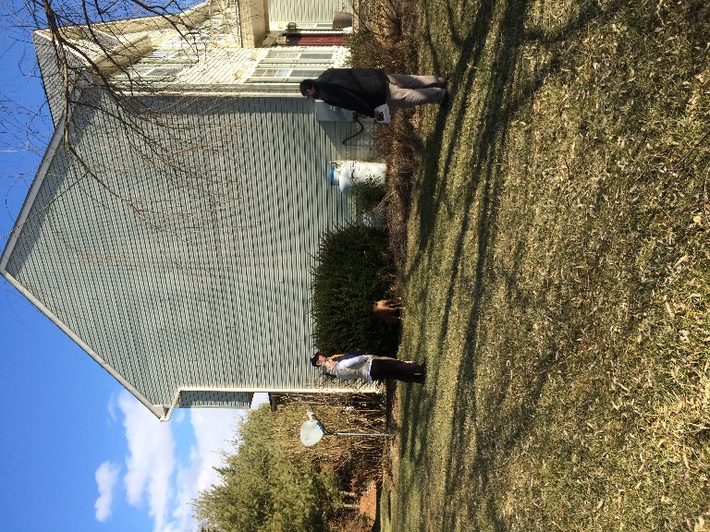
Figure 13. Rain Garden Demo site before rain garden installation
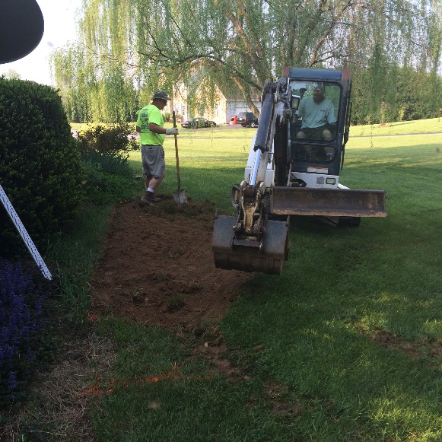
Figure 14. Kubic Construction beginning to excavate rain garden demo
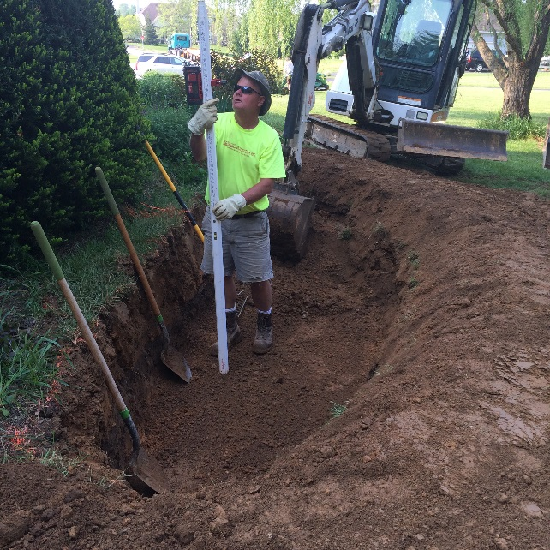
Figure 15. Kubic Construction making sure that the bottom of the rain garden is the correct depth all the way across
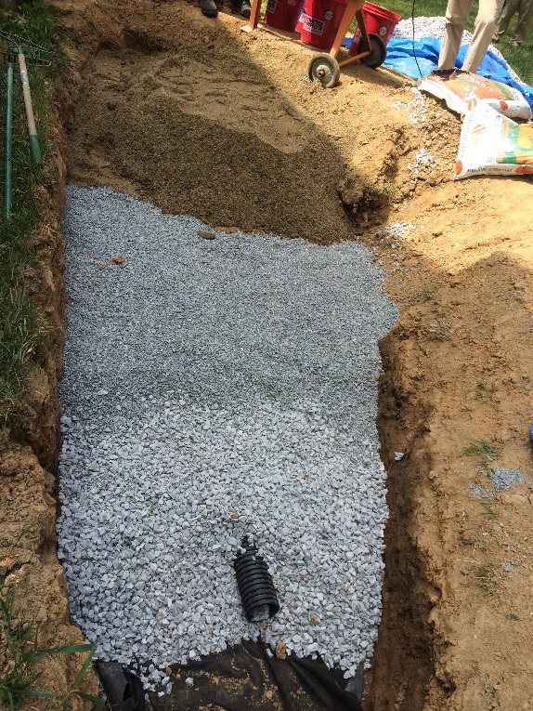
Figure 16. All of the layers of the demo garden
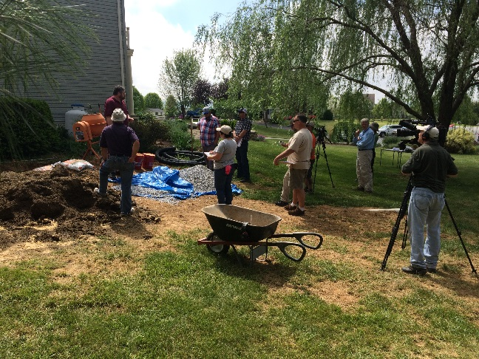
Figure 17. WV DEP explaining rain garden installation specifications to contractors
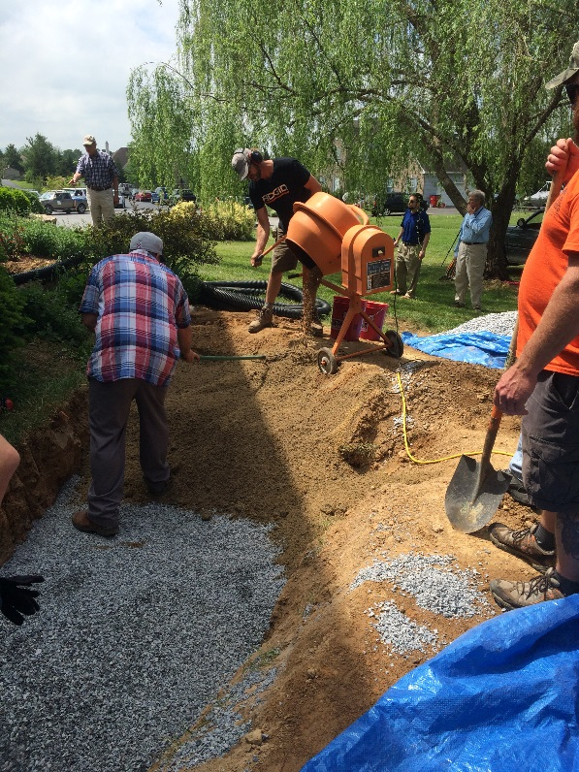
Figure 18. Training participants help install the garden!
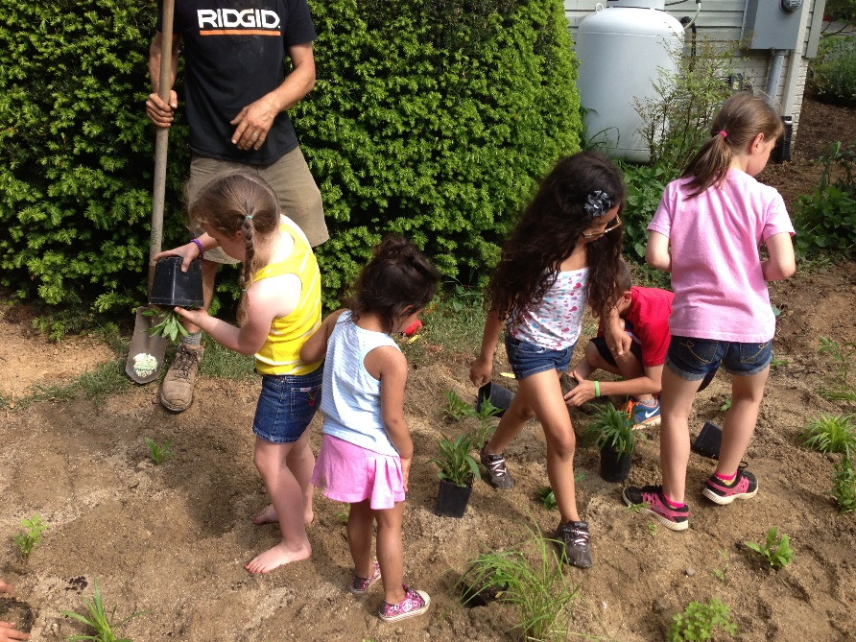
Figure 19. Neighborhood children learn about rain gardens and help plant the garden
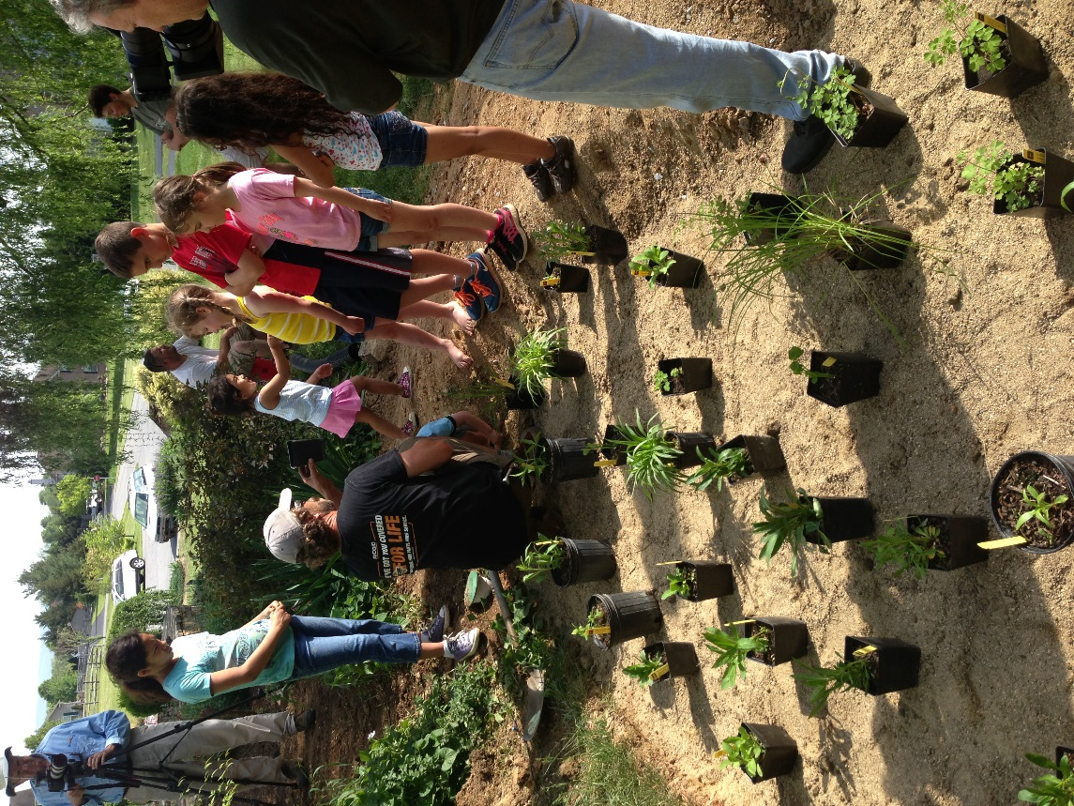
Figure 20. Neighborhood children learn about rain gardens and help plant the garden
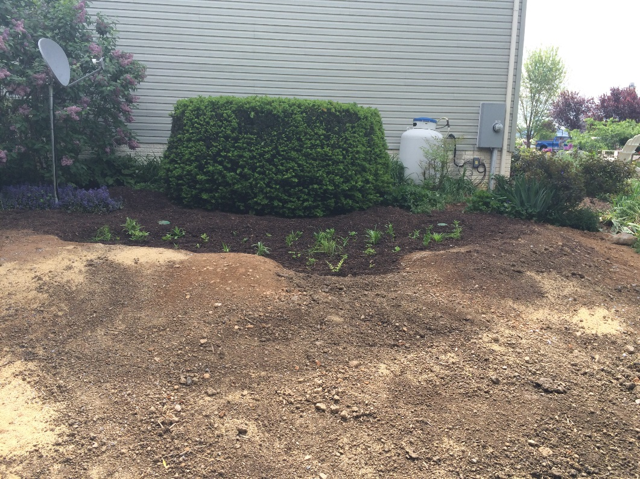
Figure 21. The planted rain garden demonstration

