Rt. 9 Bike Path Porous Paving

On June 3 and 4th, 2015 the Rt. 9 Bike Path parking lot in Martinsburg received an 800 square ft. addition of porous pavers called GeoPave. WV DOH installed the pavers, in partnership with WVCA, EPCD, WV DOH, and the Chesapeake Bay Program. The pavers consist of a geotextile liner that lays underneath just above the subsoil, a 6 inch gravel base that stabilizes the pavers and allows them to withstand the weight of heavy vehicles, and the actual paving units, which are a heavy duty plastic material that hold a 2 inch layer of stone in place through a unique cell pattern. Educational signage (pictured below) has been placed at the site that explains how the pavers infiltrate stormwater and help the Opequon River. Take a look and learn exactly how the pavers work and just how much water they will prevent from carrying pollution into the opequon!
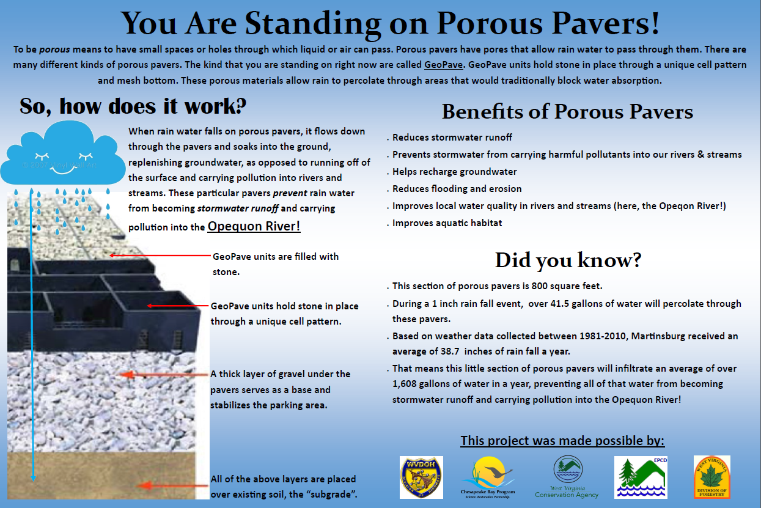

Figure 1. The educational sign that is displayed next to the pavers.
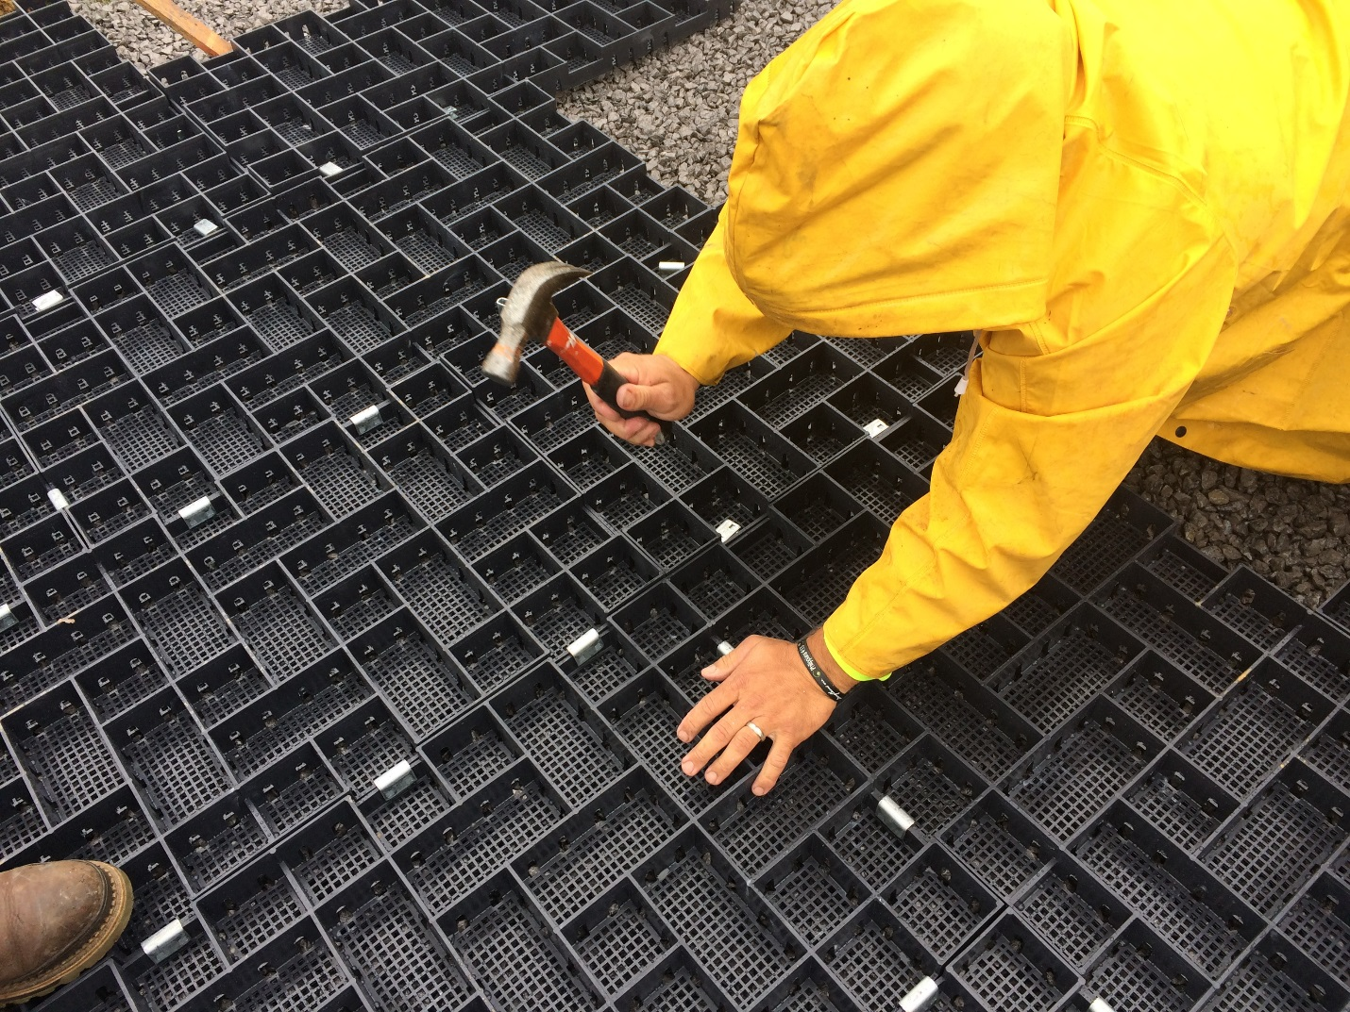
Figure 2. WV DOH hammering the clips in that hold the pavers together

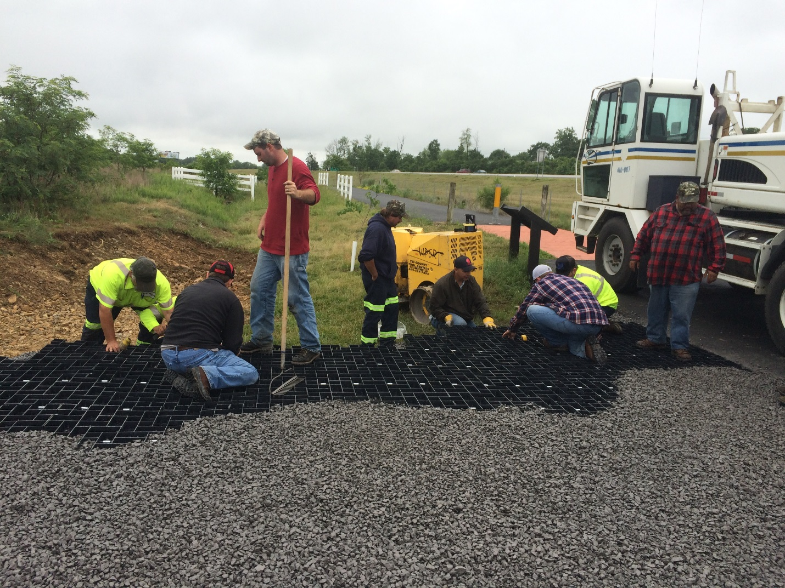
Figure 3. Many hands make light work!

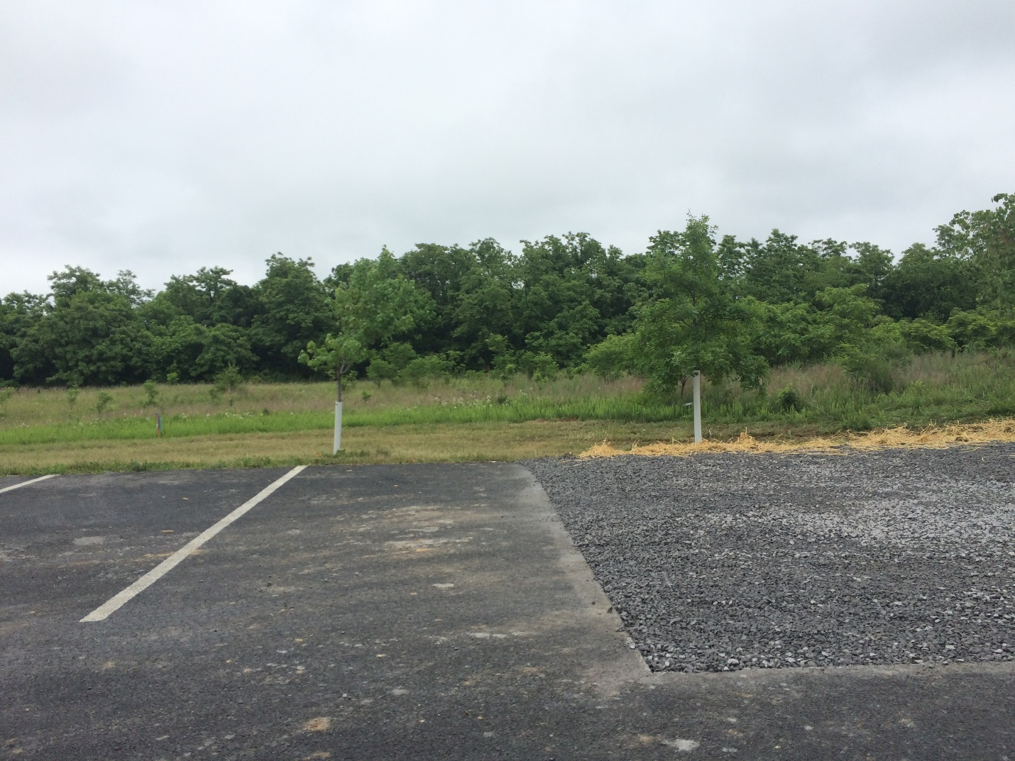
Figure 4. The finished product

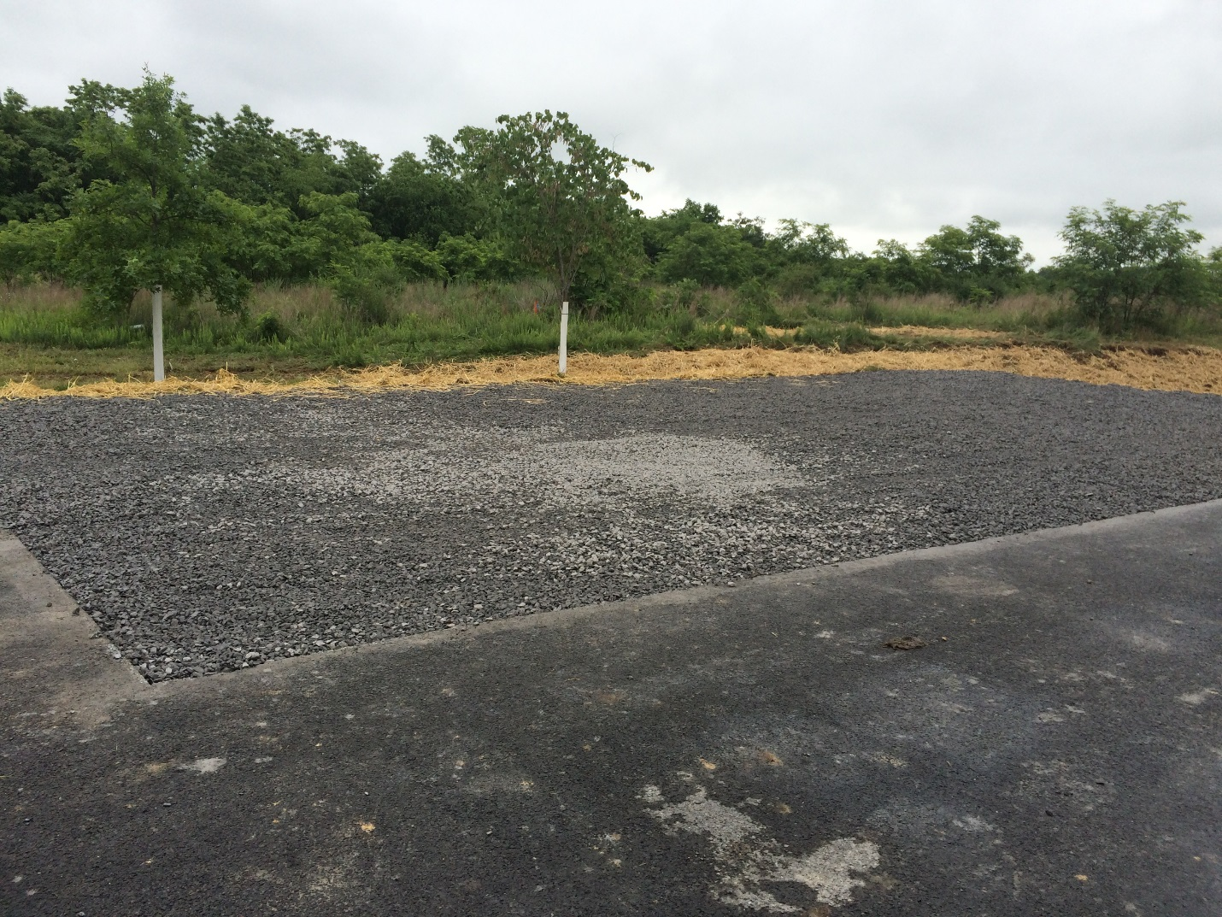
Figure 5. The finished product.

