
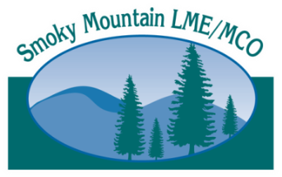
Are you ready for ICD-10?
Time is running out!

SMOKY MOUNTAIN LME/MCO TRAINING OPPORTUNITY
Preparing for ICD-10
AUGUST 5 – ASHEVILLE | AUGUST 26 – MORGANTON

Prepare for the transition to ICD-10. ICD-10 codes are four times longer thanICD-9 codes and more complicated. The crosswalk of the ICD-9 code set to ICD-10 is also more complicated. This training is for provider or payer staff responsible for diagnosing, coding or submitting claims for payment or processing. Two sessions are offered: one for clinical staff and one for financial and claims staff.

Instructor Vince Joyce is an authority on assisting behavioral healthcare providers and payers with claims management, data analysis and software system implementation. As president of e3 Informatics, he has worked extensively with N.C. Medicaid and IPRS. He has helped
providers and MCOs prepare for ICD-10 and has presented
transition trainings at statewide conferences, including NC TIDE.

What will I learn?
- How to describe format changes between ICD-9 and ICD-10
- How to recognize challenges of cross walking DSM-V and ICD-9 to ICD-10
- To understand software system changes to accommodate ICD-10
- How to select testing strategies to ensure claim systems are ready for ICD-10
- To use ICD-10 resources like the CMS general equivalence mappings (GEMS), the ICD-10 crosswalks in the DSM-V manual and several ICD-10 websites

Have questions? Call 828-225-2785 or email us
at ICD10@Smokymountaincenter.com.
REGISTER ONLINE

AUG. 5, 2015
MAHEC
Blue Ridge A and B
121 Hendersonville Road
Asheville, NC 28803

9 a.m.-12 p.m.
Finance/claims

___________________________________

1-4 p.m.
Clinical

AUG. 26, 2015
Foothills Higher Education Center Room HEC 163
2128 S. Sterling St.
Morganton, NC 28655

9 a.m.-12 p.m.
Clinical

___________________________________

1-4 p.m.
Finance/claims

