A message from our Campaign Co-Chairs

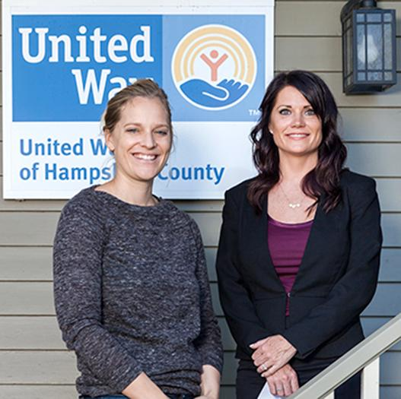

The story of this Campaign began back in September when we introduced ourselves, and shared how our love of Hampshire County fueled our enthusiasm for co-chairing this Campaign. Ultimately, the work of the Campaign will always be about the dollars we raise and invest in our community. This year, however, we challenged ourselves to both meet the Campaign goal of $1.3M while also identifying ways to diversify our base of support, to build collaborations, and to make a positive difference in people's lives in a way that moved beyond just financial support.
Here are some of the highlights of the 2016 Campaign....
We kicked off the Campaign with the Diaper Drive last summer, and we collected over 30,000 diapers. We distributed the diapers to organizations focused on the needs of young children from Ware to the Hilltowns.
In October we celebrated Downtown Northampton lifting together to build strong, vibrant, and inclusive community through the annual Downtown Lives United Day. We were thrilled to have 37 businesses participate!
This past February we partnered with our neighbors, the United Way of Franklin County and the United Way of Pioneer Valley to launch "Show the Love for Kids," our first Text to Give initiative. We led this effort to raise money for programs focused on children and youth across the Valley, and were thrilled with the positive feedback we received.
Thank you to all of you for all that you do, every day, for our community. It has been a total joy to work with you.
- Molly Feinstein & Jessica Wales

