**LIBERTY ATHLETICS**

**ATHLETICS AND SPORTS PHYSICALS INFORMATION**

Each student that participates in athletics needs to have the **OCPS SPORTS PHYSICAL** **FORM** completely filled out by a parent/guardian **and** a **Doctor** prior to try outs**.**  **The Athletic Department will not be accepting the yellow School Entry Health Exam form as dictated by OCPS Rules.** ***School Physicals are not the same as sports physicals.***  A blank **OCPS PHYSICAL FORM** can be picked up in the main office or on the web site.

Sports for Middle School are Soccer, Volleyball, Basketball, and Track. There is one sport per nine weeks. OCPS Middle School Athletics supports only one girls’ team and one boys’ team for each sport.  Tryouts will consist of 6th, 7th and 8th graders trying out for each team.

**WEDNESDAY, AUGUST 26**

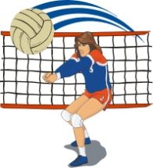**Physicals will here at Liberty!**

**Check in will be in the cafeteria.**

**GIRLS’ PHYSICALS – 7:00 P.M.**

**BOYS’ PHYSICALS – 7:30 P.M.**

**COST IS $20.00 *CASH!!***

You must bring a parent to complete the forms!

===============================================================================

**SOCCER TRYOUTS!!**

Soccer tryouts start on Thursday, August 27 after school!

Tryouts will be 4:00 – 5:30.

Meet in the locker rooms!

***You must have a current physical on OCPS forms to tryout!***

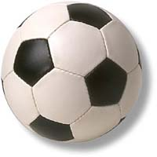**Liberty Middle School**                                     407-249-6440

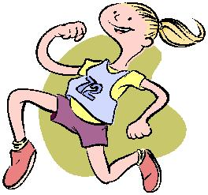**Athletic Director                                        Email:**

Gale Strain ext. 515-2333                      [**gale.strain@ocps.net**](mailto:gale.strain@ocps.net)

Any other questions or concerns,

please contact the Athletic Office