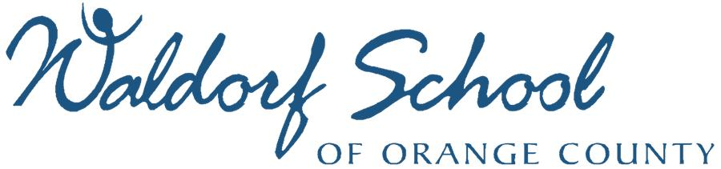
Annual Gala and Auction
May 21, 2016
Crevier Classic Cars, Costa Mesa CA
Sponsorship and Advertising Opportunities

Thank you for your interest in supporting education and an excellent cause. We are thrilled to have your support! Please contact Carolyn Gregg at (949)574-7775, ext 210 or cgregg@waldorfschool.com to explore your opportunity. We can customize packages. All sponsorships come with exposure to a grateful community, our heartfelt thanks, and may be tax deductible as we are a 501(c)(3) non-profit organization.

Diamonds are Forever Sponsorship - $10,000
10 Event Tickets (full table) ~ Event Signage ~ “Air-time” during Live Auction ~
Full-Page Spread in Event Program ~ Personal Message in Event Program ~
Opportunity for Product Placement/Advertising in Gift Bag

Goldfinger Sponsorship - $5,000
6 Event Tickets ~ Event Signage ~ Full-Page Spread in Event Program ~
Opportunity for Product Placement/Advertising in Gift Bag

Casino Royale Sponsorship - $2,500
4 Event Tickets ~ Event Signage ~ Full-Page Ad in Event Program

Skyfall Sponsorship - $1,000
3 Event Tickets ~ Event signage ~ Half-Page Ad in Event Program

You Only Live Twice Sponsorship - $500
2 Event Tickets ~ Half-Page Ad in Event Program

Teacher Ticket Sponsorship - $100
Contribute $100 to sponsor an event ticket for a teacher.

Goodwill Sponsorship – Any Amount
If you are unable to attend, or would like to show extra support, here is a great place to do it.

Advertise your business or include a personal message in the Event Program (artwork accepted in PDF and JPEG)
Full Page Half Page Quarter Page Business Card
6 ¼ x 7 ¾” 6 ¼ x 4” 3 x 4” $25
$150 $80 $50

