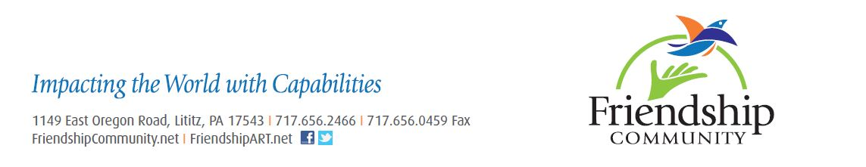

FOR IMMEDIATE RELEASE CONTACT: Mary Darrenkamp
Development Associate
(717) 656-2466 ext. 155
mdarrenkamp@FriendshipCommunity.net

Friendship Community’s 22nd Annual Fest & Auction
Friday, May 8, and Saturday, May 9

Family! Food! Fellowship!

Lancaster, PA (Monday, April 13, 2015) – You are invited to attend Friendship Community’s 22nd Annual Fest & Auction held Friday, May 8, and Saturday, May 9, at the Friendship Community corporate grounds, 1149 E. Oregon Rd, Lititz. Admission and parking are free.

A popular feature of this event is the Plant Tent. Hundreds of plants and shrubs will be available for purchase beginning on Friday at 4:00 pm, along with a large baked goods sale. Be sure to pick up a chicken BBQ dinner for $10 at the drive-thru service or stay a while at the eat-in area and listen to Spare Parts, a well-known a capella male quartet, perform at the Friday night free concert beginning at 7:00 pm.

On Saturday, a delicious pancake and sausage breakfast for $5 will be served from 7:00 am to 10:00 am. Cherry Crest Adventure Farm will feature their famous chick hatch, huge Flemish rabbits and a mini hay bail maze from 9:00 am to 2:00 pm, and kids can also get their face painted, play in the bounce house and join-in on several activities throughout the day. The large country Auction will also begin at 9:00 am on Saturday. Some items for bidding include vacation packages ranging from $300-$1,000, tickets to sporting events, themed gift baskets and adventures at many local attractions.

Since beginning twenty two years ago, this event attracts over 2,000 guests annually and has become a significant fundraiser for Friendship Community, a Christian ministry cultivating the capabilities of adults with developmental disabilities in Lancaster and Lebanon counties. To celebrate the twenty two years, Friendship is asking the community to donate $22 to fund one of three needs at Friendship Community, like new floor coverings for one of the residential homes.

Friendship Community is currently accepting donations for the auction, as well as sponsorships which include signage and promotion at the Fest, on social media and the Friendship Community website. In addition, volunteers are needed in many areas and can sign up at FriendshipCommunity.net by finding the “Fest & Auction” link under the “Events” tab.

For more details, visit FriendshipCommunity.net, like us on Facebook or contact the Events Coordinator at 656-2466 ext 112 or eventscoordinator@friendshipcommunity.net.

# # # #

