Academic Decathlon team takes second place at state, sets new team record
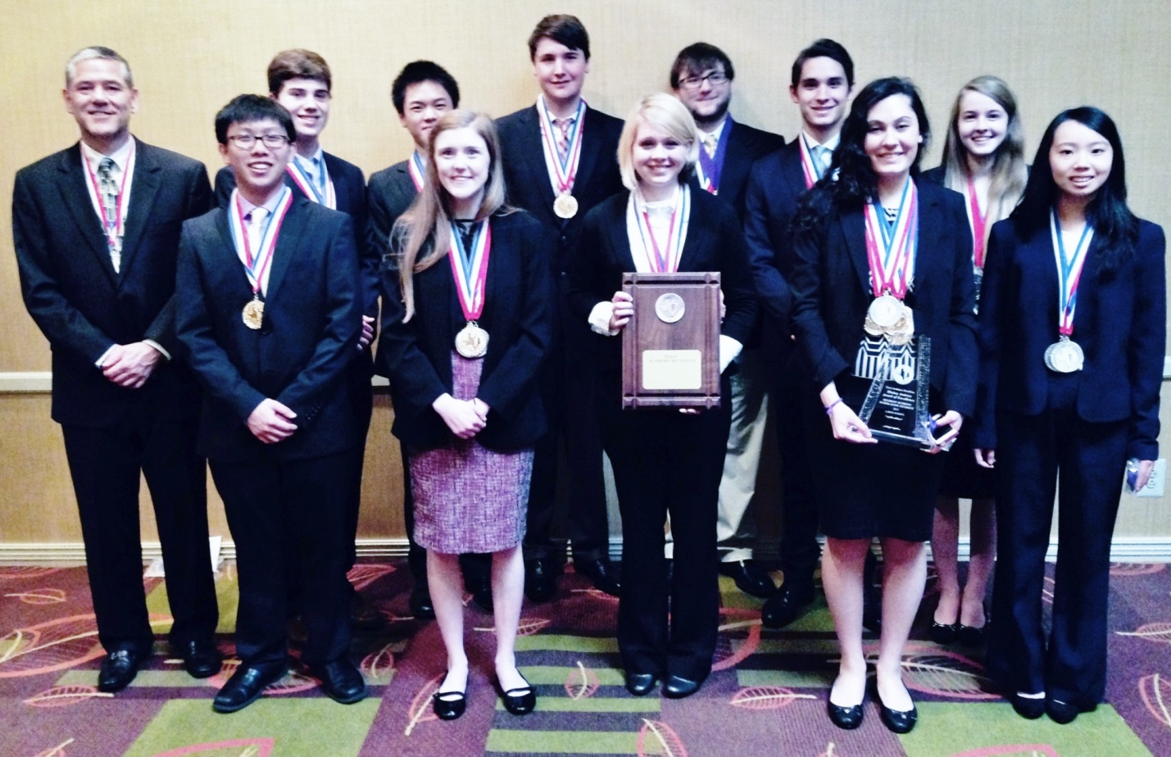

The HP Academic Decathlon team competed in the state meet and came within a whisker of their first state championship. After reclassification in the fall, HP competed in the large school division for the first time since 1992 and made it exciting down in San Antonio. Pearland won the meet with a score of 50,294, while the Scots scored 50,000.3, breaking the team record and becoming only the fifth Texas team ever to break 50,000 at the state meet. It is also only the second time in Texas AcDec history for two teams to break that mark in the same year.
"This group of Scots dedicated so much of themselves, and Coach Bergeron and I could not have asked any more of them," Coach Tom Pollock said. "Regardless of the outcome, our kids are champions, and I am sure that their futures are bright, whatever goals they set for themselves in the years to come. It was a great run, and we will never forget this group!"
Placing individually at the meet were:
Scholastic
- Rousha Nikbeh
  - individual overall champion and set a scholastic record at HP
  - individual champion in Economics, Social Science, and Language/Literature
  - Rousha earned $4,300 in scholarships
- Becky Jenkins
  - fifth overall
- Connie Jehng
  - second in Science
Honors - All three HP Honors decathletes broke the 8,000 mark with their individual scores:
- Captain David Wiegn
  - fourth overall in the Honors division
  - individual champion in both Science and Art
- Alex Gerrese
  - won the Interview competition, scoring 996.7 out of a possible 1,000
- Captain Kelsey Shipman
  - individual champion in Honors Science.
Varsity
- Jack Landen
  - won the Interview competition with a perfect score of 1,000
- Stephen Chambers
  - won the gold medal in Science
- Jacqueline Kolling
  - highest scoring HP Varsity team member
  - placed third individually in Science
All nine participants on this year's team earned scholarship money and are graduating, so there will be quite a competition as the team gears up for next season. The topic for next year is, "India," and the focus will be on India’s history, art, music, literature, ecological issues, and economics.

