DELTA SIGMA THETA SORORITY, INC.
COLLEGIATE TRANSITION TASKFORCE

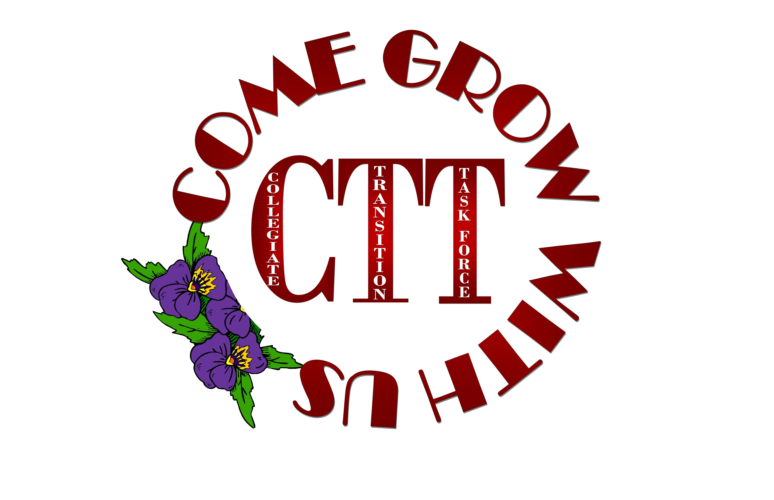
ALUMNAE CHAPTER
DIRECTORY

History/Purpose

History of the Collegiate Transition Taskforce
The Collegiate Transition Taskforce (CTT) was established to address the retention rate of collegiate members. It is a fact that most members of our illustrious sorority become disconnected immediately after college. The CTT’s charge is to help increase the transitioning rate of collegiate members to alumnae chapters by guiding and serving as a tool for collegiate members to connect with an alumnae chapter before they graduate.

Purpose of CTT
- To help increase the transitioning rate of collegiate members to alumnae chapters
- To help guide and foster a sisterly relationship between collegiate and alumnae sorors and chapters
- To assist collegiate sorors to locate an alumnae chapter at their post-graduation location
- To smooth the transition from collegiate to alumnae chapter
- To build lasting relationships among collegiate and alumnae sorors
- To build an understanding and appreciation of collegiate and alumnae chapter functions

Purpose of the Collegiate Transition Alumnae Chapter Directory
The Collegiate Transition Alumnae Chapter Directory is a tool that will assist collegiate members, as they transition from their collegiate chapter to an alumnae chapter. The directory contains the alumnae chapter name, location, email address, name of the CTT/Member Service chairperson, meeting day and if the chapter waives chapter dues for collegiate members transitioning immediately upon graduation.

The Charismatic & Courageous Central Region

The Dynamic and Historic Eastern Region

The Dynamic and Historic Eastern Region

The Dynamic and Historic Eastern Region

Strategic in Sisterhood and Service … The Farwest Region

Strategic in Sisterhood and Service … The Farwest Region

Magnifying the Mighty … The Midwest Region

Magnifying the Mighty … The Midwest Region

Magnifying the Mighty … The Midwest Region

The “Sensational” South Atlantic Region

The “Sensational” South Atlantic Region

The Dynamic Southern Region

The Dynamic Southern Region

The Dynamic Southern Region

The Dynamic Southern Region

The Dynamic Southern Region

The Blazing Southwest Region

The Blazing Southwest Region

Chapters that did not respond to the survey

(100% response to the survey from the Midwest Region and Southern Region)

Chapters that did not respond to the survey

Transition Resources

Chapter Locator
- Collegiate members can now search for chapters in the location where they anticipate living after graduation
- Allows collegiate members the opportunity to make contact with the alumnae chapter prior to moving to the area
- Will provide a very important opportunity for collegiate members to begin building their support system in anticipated new city

Collegiate Registration Process
- Collegiate members are to input their anticipated graduation date and post-graduation location in the Sisters Only Member Portal
- After registration, registrant will be given the contact information for an alumnae chapter(s) in the specified area
- This process will also assist CTT in keeping track of how many collegiate members are graduating each year

The Chapter Locator can be found on the National website http://www.deltasigmatheta.org/chaplocation/home_locator.asp

Delta Sigma Theta Sorority, Inc.

National Collegiate Transition Taskforce Members

2013- 2015
Sherina E. Maye, Co-Chair – MW
Aeriel Scott, Co-Chair – SO
Tawanda Mercer – C
Sharon Williams Jackson – EA
Natice Locke – FW
Kedada Bethel – MW
Karyn Aguirre – MW
Sarahjini Nunn – MW
Patience Canty - SA
Tanya Mitchell Cobb – SO
Shawan Hagan – SW
Sabrina Curtis – SW

ctt@deltasigmatheta.org

