Mercer Island FC hosts Sounders Women match at MIHS

Sounders Women defender Stephanie Spierkman pushes for possession up the field against the Portland Spartans June 11 at Islander Stadium. Mercer Island FC hosted the soccer match. (Photo courtesy of Garth and Molly Fort).

For the second year in a row, the Mercer Island FC soccer club hosted a Sounders Women match at Mercer Island High School stadium. On June 11, the Sounders Women took on the Portland Spartans in a Women's Premier Soccer League (WPSL) regular season match. Despite intermittent rains throughout the match, a nice crowd turned out to see the collegiate players display their soccer skills.
After a pre-match clinic for Mercer Island FC and Eastside FC girls conducted by the players, the Sounders Women came out strong against an overmatched Portland squad. Applying pressure throughout the game, the Sounders dominated and the scoreboard read 7-0 when the final horn sounded. Sounders Women leading scorer Karli White (Seattle University) netted a hat trick (3 goals) for the match. Megan Connolly (Florida State), Kate Bennett (University of Washington) and Mora Johnson (Rollins College) also scored for the Sounders. Sounders keepers Cassie Miller (Florida State) and Kori Butterfield (University of Tampa) split time in the goal to earn the shutout as they turned away the few scoring chances the Spartans were able to muster. After the match, the Sounders Women signed autographs and took pictures with the youth players and fans in the crowd.
"The opportunity to partner with Mercer Island FC and play on the Island is an important one for us," said Darren Sawatzky, director of the Sounders Women and U23 programs. "They are one of the top clubs in the state and we love showcasing our college players in their community." Mercer Island FC president Toby Suhm said, "we were very impressed with the quality of the play by the Sounders Women and the way their staff managed every aspect of the match. We are already in discussions with them to host another match next year."
Founded in 1964, Mercer Island FC (MIFC) has provided the community's youth with unmatched opportunities to learn and play the world's game of soccer for the past 50 years. With a dedicated cadre of both paid and volunteer coaches, staff and board members, MIFC has become a pillar of the Mercer Island community. The club offers outstanding developmental soccer to players from ages 5-18 through the Micro and Recreational soccer programs. MIFC Select teams start at age 10 and compete with the top clubs in the state where they routinely bring home tournament trophies and state championship titles. MIFC is one of five local member clubs of Eastside Youth Soccer Association (EYSA), all of which provides Recreational and Select levels of competition. Players who are interested in a higher level of competition and commitment can try out for MIFC's sister Premier club, Eastside FC, based in Preston.
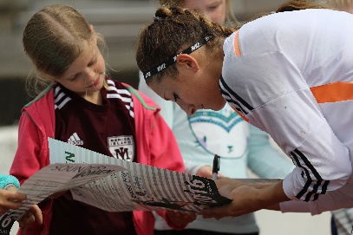
The Women's Premier Soccer League is a national women's soccer league in the United States and Puerto Rico, and is on the second level of women's soccer in the United States soccer pyramid, below National Women's Soccer League (NWSL).

