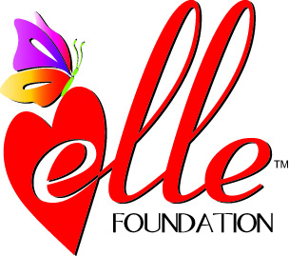
ELLE FOUNDATION INC.
CREATING MEMORIES OF JOY FOR CHILDREN WITH CANCER BY GRANTING FINAL WISHES FOR CHILDREN
BATTLING A RECURRENCE

Donor Information:

Please Print
_______ __________________ _________________________
Title First Name Last Name

______________________________________________________________________________________
Business Name (if applicable)

______________________________________________________________________________________
Street Address

______________________________________ __________ ________________
City State Zip Code

Phone #:_______________________________ E-Mail Address: ___________________________________

Contribution: ______$50 _____$100 ____$250 ____$500 ____$1000 ____Other $________

My Donation is: ______ In Honor of ______________________________ Occasion___________________
(i.e. birthday, anniversary, marriage)
______In Memory of ______________________________

______In Memory of Lauren’s life and legacy

Please complete the section below if you would like a Letter of Donation Notification sent to the
person/family named above (in honor or in memory of):

_________ ___________________________ __________________________________________
Title First Name Last Name

__________________________________________________________________________
Street Address

______________________________________ __________ ________________
City State Zip Code

Mail this form, along with your check payable to the Elle Foundation Inc., to:
Elle Foundation Inc.
P.O. Box 8068
Bridgewater, NJ 08807-8068
www.ellefoundation.org

ELLE FOUNDATION INC. QUALIFIES FOR MANY COMPANIES’ MATCHING GIFT PROGRAMS.
EMPLOYEES CAN DIRECT THEIR AT-WORK UNITED WAY DONATIONS TO THE ELLE FOUNDATION.
LIKE US ON FACEBOOK AT ELLE FOUNDATION INC NEWS.

Check#: Check Date:

Elle Foundation, Inc. (Tax ID # 26-4755717) is a 501(C)(3) tax-exempt non-profit organization.

