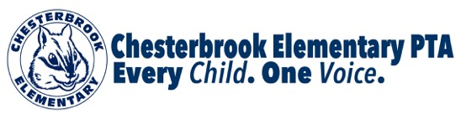
Renew your PTA Membership TODAY and win a chance for dinner at
RIO GRANDE or TRUE FOOD KITCHEN!

It’s not too late to join the PTA! Anyone who is registered for the current school year from May 1, 2015 until March 11, 2016 will be entered into a drawing to win a $50 gift card to Rio Grande in Arlington or a $50 gift card to True Food Kitchen in the Mosaic District in Fairfax. All registrations must be received by Friday, March 11th at noon. The drawing will be held Monday, March 14th at 10:00 am, so check your emails that morning!

** Unsure if you joined the PTA or renewed your PTA Membership this school year? Please email Elysha King, VP Membership at elyshadking@gmail.com for confirmation.

Register TODAY by filling out this form and attaching a check for $10 (single membership) or $20 (family membership) made payable to Chesterbrook Elementary PTA. You can also register by visiting our website at www.chesterbrookpta.org

Parent Name _______________________________

Parent Name _______________________________

Oldest Child’s Name _______________________________

Oldest Child’s Teacher _______________________________

Contact email _______________________________

Thank you to all the families who have already joined for the 2015-16 school year. By supporting the PTA, you are supporting your children and helping make Chesterbrook the exceptional school that it is!

