
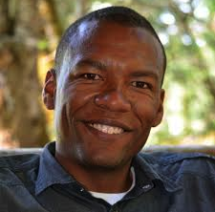
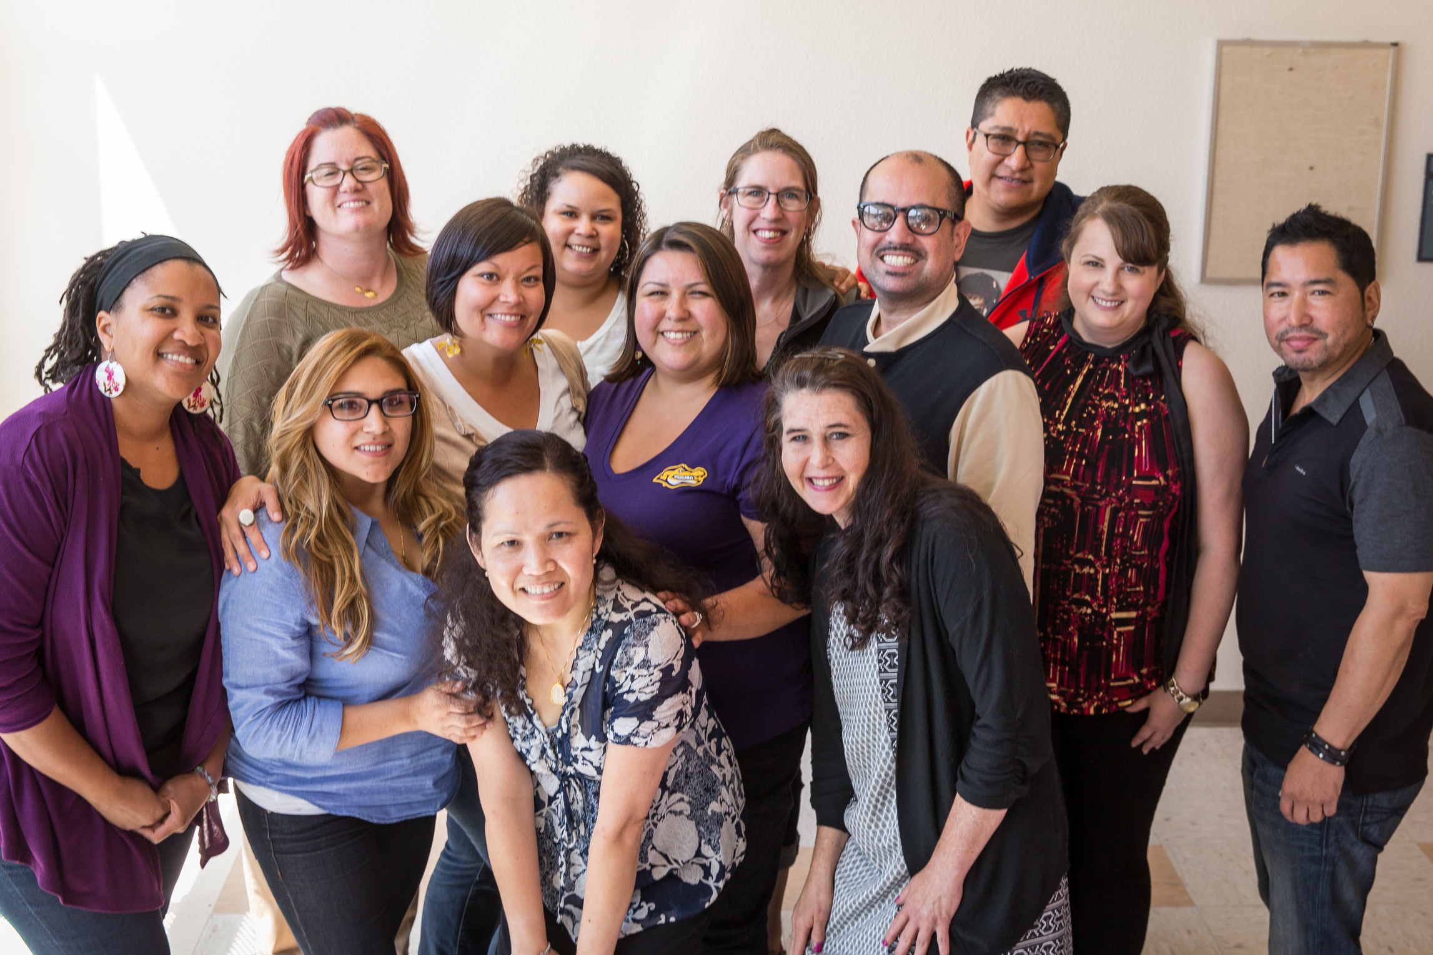


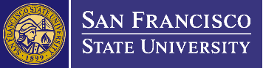
Fall 2016 application deadlines:
- Early Priority: February 1, 2016
- Final Deadline: April 1, 2016

Find out more at an Informational Session
at SF State in
Burk Hall 321 at 6 p.m.

Thursday, December 17, 2015
Thursday, January 14, 2016
Thursday, February18, 2016

Or go to http://edd.sfsu.edu
“The EDDL program opened my eyes and gave me a framework to lead my community college in creating more opportunities for students’ success, particularly for first generation students of color.”

“I use the materials and skills learned on a daily basis to help lead a school site.”
EDUCATIONAL LEADERSHIP DOCTORAL PROGRAM
at San Francisco State University

