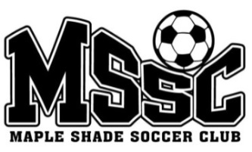
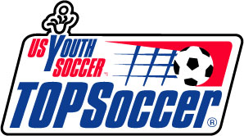

Moorestown Department of

Parks and Recreation

BUDDIES NEEDED!

The Maple Shade Soccer Club and the Moorestown Department of Parks and Recreation have collaborated to offer TOPSoccer Program. TOPSoccer is sponsored by the Law Offices of McDowell, Posternock, Apell, and Detrick, PC.
TOPSoccer is an inclusive program open to individuals ages 4-21 with special needs. The program offers a modified version of the game of soccer designed to provide a fun, relaxed, and active environment for children with special needs to participate with the help of a “Buddy.”
Buddies are volunteers who pair up with an athlete to support, encourage, and assist them throughout our season.
Buddy Requirements:
- Middle school, high school or above aged individuals, and/or a sibling to someone with a disability
  - We do also accept mature younger buddies
- Works well with children
- No soccer experience needed
- Has a fun, positive, and energetic attitude
- Completes a training session
- Committed to at least half of the Saturday morning games starting March 21st
Registration is open on the Maple Shade Soccer Club website. Season runs on Saturdays from MARCH 19TH to MAY 14TH (excluding March 26th) from 9:00-10:00am.
If you want to become part of this organization as a buddy, please e-mail Catherine (Kate) Devone at Catherine.a.mccarthy@gmail.com or visit www.mapleshadesoccer.net and write buddy under team.

