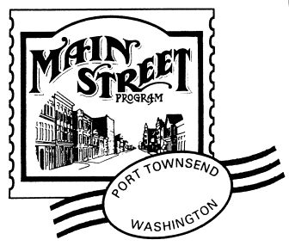

UPTOWN STREET FAIR PARADE WAIVER
Saturday, August 15, 2015 Parade at 2 pm!

INDEMNIFICATION AGREEMENT

I/We wish to participate in the Uptown Street Fair Parade. The individual(s) or organization identified below shall, as a condition for participation, indemnify and hold harmless the City of Port Townsend, Jefferson County, Port Townsend Arts Guild and the Port Townsend Main Street Program from any and all claims, lawsuits, losses, damages or expenses on account of bodily injury or property damage arising out of their participation in the Uptown Street Fair Parade. No political or religious entries please.

INSURANCE & OTHER REQUIREMENTS All motorized vehicles and equestrian entries MUST provide their own insurance and provide proof of it with application. We MUST have evidence of your insurance in our possession setting forth the limits of liability provided and the name of your insurance company BEFORE we can accept your entry into the Uptown Street Fair Parade. Public safety first! All entries will be safe, and appropriate in a crowded public setting*. Entries admitted at the discretion of the Uptown Street Fair Planning Committee and the Port Townsend Main Street Program.

Organization/Business/Individual(s) Name (printed):
________________________________________________________________________________________________________________________________________________________

PARADE ENTRY DESCRIPTION: __________________________________________________
____________________________________________________________________________
____ If it is a motorized or equine entry, insurance information is attached.

Authorized Organization/Business/Individual(s) Signature(s):
________________________________________________________________________________________________________________________________________________________
Date: __________________________
Thank you,
The Port Townsend Main Street Program
211 Taylor Street, Suite 3 Port Townsend, WA 98368
(360) 385-7911 www.ptmainstreet.org
The Port Townsend Main Street Program is a 501c3 nonprofit organization.

