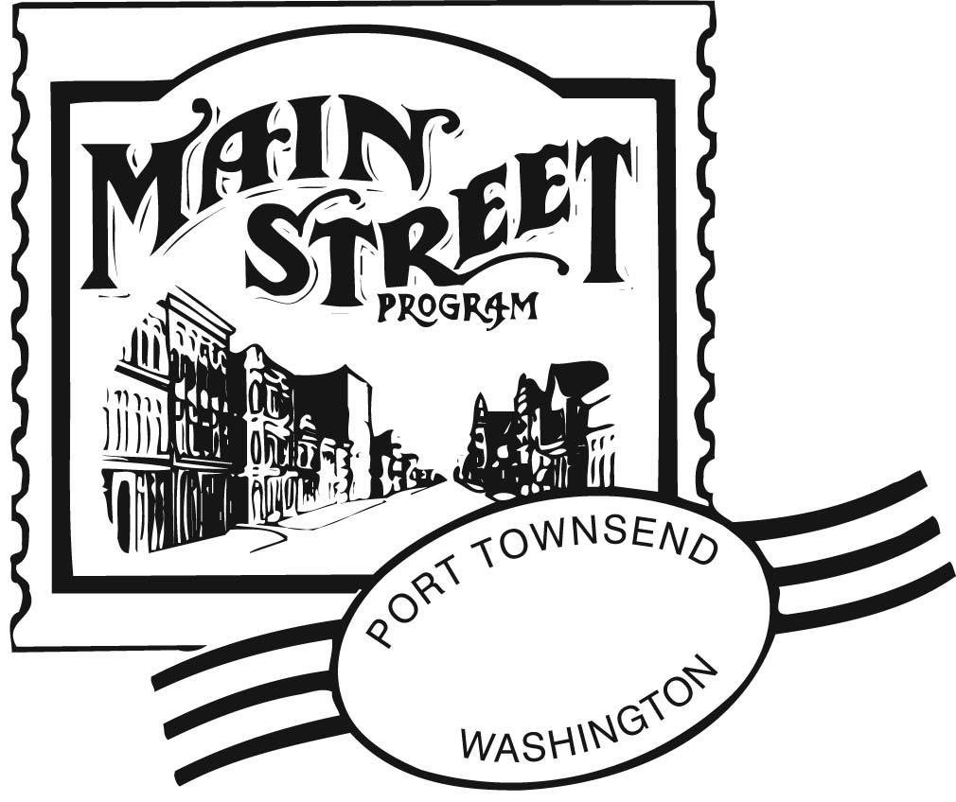9-11-15

FOR IMMEDIATE RELEASE
For more information contact Mari Mullen, Executive Director director@ptmainstreet.org

FALL CYCLE: LENT (Light at the End of the Tunnel) MICROLOAN FUND
APPLICATION DEADLINE OCTOBER 15, 2015

Port Townsend Main Street Program
Low Interest Loan Program for Port Townsend’s Commercial Historic Districts

The Port Townsend Main Street Program’s LENT Low-Interest Microloan applications are due October 15, 2015. These funds are a tool to offset some of the financial impacts businesses endure from emergency situations, although business development proposals will be considered. The funds are made available through the Port Townsend Main Street Program which fosters economic vitality and preservation of place within the historic business districts, while maintaining our small town quality of life.

Priority will be given to business owners with shops in the commercial historic districts (Uptown/Downtown) that are experiencing a loss of business due to natural disaster, infrastructure failure, major equipment failure, etc. Priority will also be given to impactful infrastructure projects that would benefit not only the business applying, but neighboring businesses and the local economy as well. Business growth projects will also be considered, but only in deference to emergency projects (Main Street earmarks $4000 in funding for emergencies only). If you are unsure whether or not your project qualifies, please call or email the Main Street office to discuss it. Even if we can’t fund your project through LENT, we may be able to point you in the right direction.

Businesses that would otherwise qualify for conventional financing will not be considered for LENT Microloans.

Minimum Loan $500/Maximum Loan $4000;
0% interest for one year; payoff within three years with incremental interest rate increase up to 5%. (Note that amounts under $1,000 must be repaid in one year.)

--more—

Upcoming Quarterly Application Dates

October 15, 2015
January 15, 2016
April 15, 2016
July 15, 2016

View and print out the application at www.ptmainstreet.org click “Microloan Deadline 10/15” tab.

For more information please contact the office at (360)385-7911 or email Mari Mullen, Executive Director, at director@ptmainstreet.org

