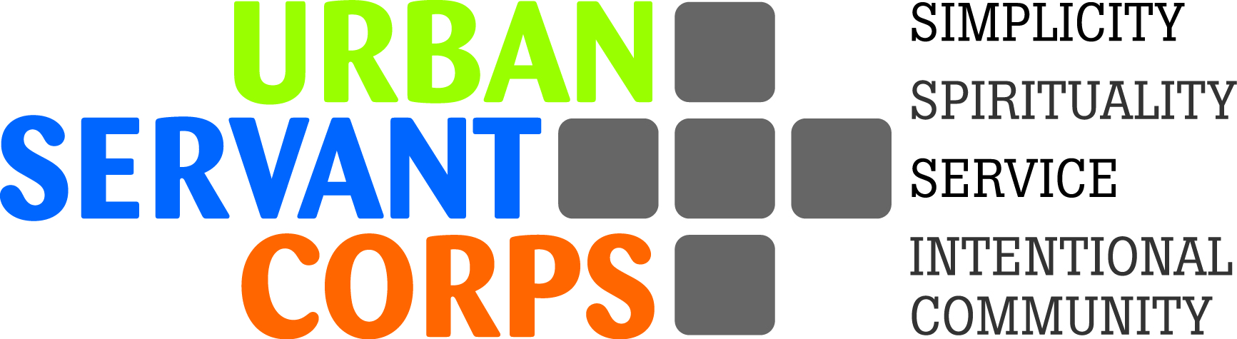

MISSION: Urban Servant Corps is a faith-based, intentional community of full-time volunteers who seek to live simply while serving and accompanying those most in need at non-profit partner agencies in the heart of Denver.

Urban Servant Corps
Community Life Coordinator
Job Description

Responsibilities:
Collaborate with Executive Director and USC volunteers in program planning and community life, including the following:

- Recruit and engage full-time volunteers for upcoming program cycle, process applications and conduct interviews
- Plan and lead USC volunteer orientation, trainings, and retreats
- Plan and attend weekly community nights (Monday) and monthly community days (Friday)
- Coordinate volunteer committees/liaison positions for community life responsibilities and activities
- Connect volunteers with leadership opportunities in the community
- Support interpersonal and community relationships during times of conflict
- Offer mentorship around the USC tenets of simplicity, service, spirituality and intentional community
- Supervise intern and other regular external community volunteers
- Assist Executive Director in fundraising and outreach activities
- Other duties as assigned

Requirements:
-- Bachelor’s Degree
-- Dedication to Urban Servant Corps mission and issues of social justice
-- Commitment to uphold Urban Servant Corps tenets of intentional community, simplicity, service, spirituality
-- Comfortable leading discussions regarding faith traditions from a variety of perspectives
-- Demonstrated skills (minimum 2 years experience) in conflict resolution and consensus based problem solving with young adults

Preferred:
-- Experience with intentional community life
-- Experience within diverse communities
-- Affiliation or familiarity with the Lutheran (ELCA) faith tradition

Reports to Executive Director of Urban Servant Corps
Full-time position, salary range: $33,000-$36,000, benefits and PTO available
Flexible schedule (outside of mandatory community nights, fundraising events, retreat weekends)
Some weekends and evenings as well as travel for recruiting purposes.

Please submit resume and cover letter to Executive Director, Krista Kilgus at: jobs@servantcorps.org. Priority consideration will be given to those submitted by June 3.

