The Building Blocks of Love:
Co-Creating a Happy Relationship

Carista Luminare, Ph.D. and Lion Goodman
www.ConfusedAboutLove.com

Part II

The Amygdalae, Danger Detection, and the LoveStyles™

Our ancient limbic system, and the amygdala in particular, is the brain center tied to our sense of safety or danger. In his books Just One Thing, Buddha’s Brain, and Hardwiring Happiness, Rick Hanson invites us to engage in important and effective self-regulation practices so we can better deal with the anxieties and vicissitudes of life. This mindful approach, and the practices, enable us to calm ourselves, settle down our limbic alarm system, rewire our brains, and live a happier, more fulfilled life. Personal transformation and neurological rewiring have a direct impact on how we live, how we relate to others, and how we interact with the world.

We’ve found, however, that many of the most mindful, conscious, and personally transformed people we know still have significant problems in their primary relationship. Mindfulness practices do not, apparently, automatically transform an individual’s ability to interact lovingly with their romantic partner. When we get triggered, mindful centeredness flies right out the window.

The ability to self-regulate is a crucial life skill, yet relationships require co-regulation, which is a different skill altogether. Living alone is one solution – there’s no one around to trigger you. Couples and families, on the other hand, are forced into close quarters with others who can easily feel like threats to their vulnerable primitives. You can “pet your lizard” (as Rick recommends) to soothe your primitive brain and quiet your fears, but what do you do when your partner’s lizard brain feels cornered and attacks?

We each have reactive landmines planted deep in our subconscious mind, and our partner’s behavior can easily trigger them. If you sense a potential threat (such as your spouse getting upset or angry with you), your amygdala might shift from feeling safe and secure, in the “green zone,” into the highly alert and cautious “yellow” state. The landmine is now armed – it is hypersensitive to any additional threat. Any small slight, such as a false accusation or an unkind word, can trip it. When that happens, your neurology goes reactive. Real danger gets responded to immediately. Your amygdala enters the “red danger zone” and you may respond with behaviors that you’ll feel embarrassed by, or later regret. Your primitive brain has hijacked your ability to practice mindfulness. In fact, you’ve “lost your mind” – or at least your ability to consciously self-regulate.

In an ideal world, at moments like this, you can depend on your partner to provide you with reassurance and care. “It’s okay, honey. You’re safe, I’m here, and I’ve got you. Come on over here and get a big hug.” This soothes your frightened inner child, and your amygdala can de-escalate and relax. Safely embraced, your limbic system quiets from emergency red to cautious yellow, and eventually it settles back into the calm green zone of safety. “It’s okay, the danger has passed. I’m loved.”

In our next segment: Landmines and Independence

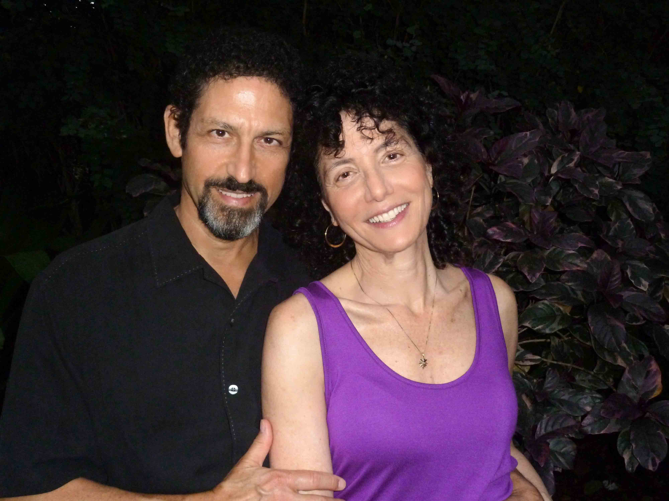

Bios:

Carista Luminare, Ph.D. and Lion Goodman are co-founders of Luminary Leadership Institute, a consulting firm dedicated to bringing leaders of businesses and organizations into alignment with their highest virtues and their True Self. They are co-creators of Confused about Love? coaching services and training programs. They are currently writing a book on The Building Blocks of Love.

Carista has 30 years experience as a consultant, counselor and coach to executives, entrepreneurs, individuals and organizations. She has developed a comprehensive holistic parenting methodology and LLI’s leading-edge evolutionary leadership program. In her private healing practice, she integrates her lifelong research on childhood attachment and adult relationship dynamics. Carista is the author of the groundbreaking book, Parenting Begins Before Conception.

Lion has 35 years experience as an executive coach, counselor, and healer. He has served more than 400 C-suite executives, business owners, and change agents around the world. He created The BeliefCloset Process, a proprietary methodology for shifting beliefs at the core of the psyche, which he teaches to coaches and therapists around the world. He is the author of three books: Creating on Purpose; Transform Your Beliefs; and Menlightenment.

