**KING OF THE PLATEAU**

***7 on 7 &***

***BIG MAN CHALLENGE***

EHS is offering a FREE 7 on 7 and Big man Challenge!

*GREAT WAY TO BUILD TEAM UNITY & COMPETE!*

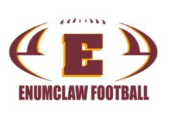

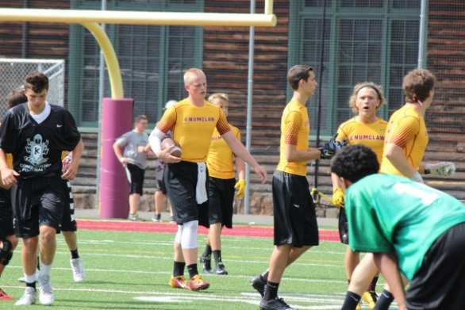 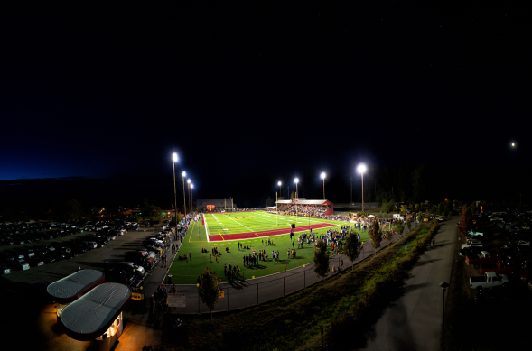

**Can you be the King of the Plateau?**

**OFFICIALS PROVIDED  
- Each Official has a four second timer for QBs (QB TEE)**

**Teams include:**

**Curtis**

**Sumner**

**Kentwood**

**Kent-Meridian**

**Emerald Ridge**

**Enumclaw**

**Auburn Riverside**

**Tahoma**

Double Elimination Tournament

Thursday

-Each team is guaranteed 2 games IN TOURNAMENT (More games outside bracket if you choose).

* Players will receive Water and Hot dogs
* Winning Team Receives Championship T-Shirts

-Games start at 1:00pm for seeding

6:00 Tourney starts, under the lights!

-Big Man Contest During 7 on 7 (5 man)

[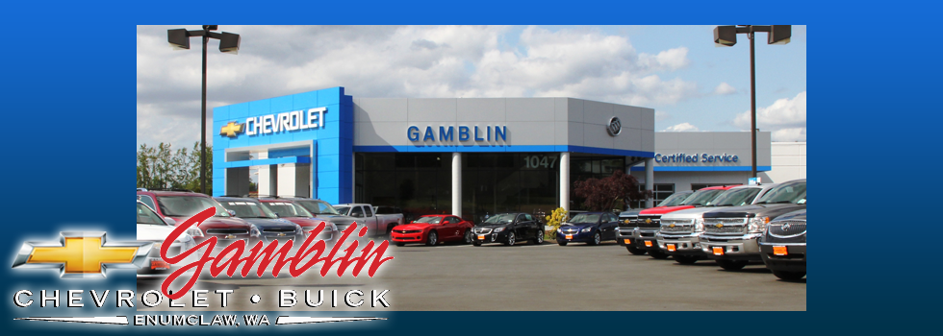](http://www.gamblinmotors.com/HoursAndDirections?cs:a:i=GM_Chevrolet-Showroom_HomePage-Chevrolet-Emblem_Hero-Image-Rotator)

**Head Coach Mark Gunderson**

[mark_gunderson@enumclaw.wednet.ed](mailto:mark_gunderson@enumclaw.wednet.ed)

Enumclaw Football Foundation

[enumclawfootballfoundation@gmail.com](mailto:enumclawfootballfoundation@gmail.com) www.enumclawfootball.com

[EHS]

Mid-Week

in the

‘CLAW

*Home of football Fans!!!*

*July 21*

*1:00pm-8:30pm*