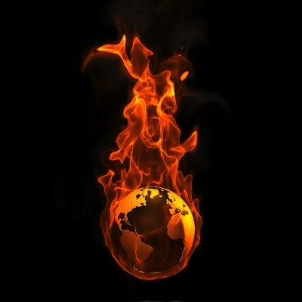

For more information and to register for free, go to:

<https://fire-ed-training.eventbrite.com>

Or contact

andi.thode@nau.edu **•** [christine.mares@nau.edu](mailto:christine.mares@nau.edu)

photo credit: wikinut.com

The World of Wildland Fire

We are looking for collaborators to grow this ground-breaking concept. Come see what we have done so far, and join us as we move forward!

**AFE Conference 2015**

**San Antonio, TX**

The Wildland Fire Education and Training Collaborative Invites You To

**SAVE THE DATE!**

**MONDAY, NOV 16**

**1-5PM**

**Vision Statement**

Our vision is to provide and connect fire science educators and trainers with scientifically solid and peer-reviewed teaching tools and techniques, using state-of-the-art materials, which will be free and accessible to all. This is done to significantly enhance the learning experience.

**Mission Statement**

To develop multiple sources of media, including but not limited to books, videos and classroom exercises, for the purpose of synthesizing the knowledge in fire science and to build a structure from which to move from. This will be a joint effort across academia, government institutions and NGOs. Existing media can and will be used in the larger structure and all materials will be peer-reviewed before being released as part of the framework.

**What is The Wildland Fire Education and Training Collaborative (WETC)?**