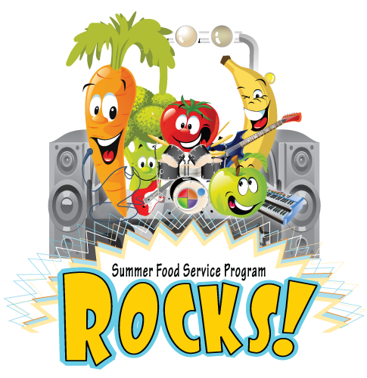

SUMMER FOOD PROGRAM LUNCH MENU 2015

Monday | Tuesday | Wednesday | Thursday | Friday
USDA IS AN EQUAL OPPORTUNITY PROVIDER.  Lunch free to children ages 1-18. Adults over age 18 pay $3.60 for lunch. | 26 - MAY  DELI HAM SANDWICH/MAYO  BABY CARROTS/RANCH  PEAR SLICES  MAYO & MUSTARD  LIGHT RANCH CUP | 27  HAMBURGER ON A BUN  BAKED BEANS  HAWAIIAN PINEAPPLE  CATSUP & PICKLE SLICES | 28  POPCORN CHICKEN  CAULIFLOWER/RANCH  WHEAT DINNER ROLL/MARG  MANDARIN ORANGES  BBQ SAUCE | 29  TACO MEAT / CHEESE & CHIPS  ROMAINE & CHEESE MIX  CORN  FRUIT COCKTAIL  SALSA
1 - JUNE  PORK RIB PATTY ON BUN  CUCUMBER SLICES/RANCH  SLICED PEACHES  BBQ SAUCE | 2  MINI CHICKEN CORN DOGS  POWER PASTA SALAD  FRESH GRAPES  BABY CARROTS/RANCH  CATSUP & MUSTARD | 3  BAKED CHICKEN DRUMSTICK  POTATO SALAD  FRESH APPLE WHEAT DINNER ROLL/MARG | 4  CHEESE STICKS WITH MARINARA  GREEN BEANS  HAWAIIAN PINEAPPLE | 5  DELI TURKEY ON WHEAT/  MAYO OR MUSTARD  CHEDDAR SNACK MIX FRESH BROCCOLI  FRESH PLUMS LIGHT RANCH CUP
8  STEAK FINGERS  PEAS  HAWAIIAN PINEAPPLE  WHEAT DINNER ROLL/MARG  BBQ SAUCE | 9  CHICKEN FILLET ON BUN  FRESH BROCCOLI  APPLESAUCE  BBQ SAUCE LIGHT RANCH CUP | 10  BEEF HOT DOG ON A BUN  CARROTS & CELERY/RANCH  FRUIT COCKTAIL  CATSUP & MUSTARD | 11  SPAGHETTI/MEAT SAUCE  ITALIAN VEGETABLE BLEND  PEAR SLICES  GARLIC BREAD | 12  HAM/CHEESE SANDWICH  FRESH BROCCOLI/RANCH  SUNCHIPS FRESH GRAPES  MUSTARD
15  CORNDOG SLICED PEACHES  CUCUMBER SLICES/RANCH  CHEDDAR SNACK MIX  CATSUP & MUSTARD | 16  CRISPITO REFRIED BEANS TORTILLA CHIPS FRESH KIWI WEDGES  SALSA | 17  HAMBURGER ON A BUN  BAKED BEANS  HAWAIIAN PINEAPPLE  CATSUP & PICKLE SLICES | 18  CHICKEN NUGGETS  CAULIFLOWER/RANCH  BERRIES & BANANAS  WHEAT DINNER ROLL/MARG  BBQ SAUCE | 19  MACARONI & CHEESE LITTLE SMOKIES  FRESH BROCCOLI/RANCH  PEAR SLICES  BBQ SAUCE
22  PORK RIB PATTY ON BUN  CUCUMBER SLICES/RANCH  MANDARIN ORANGES  BBQ SAUCE | 23  TACO MEAT / CHEESE & CHIPS  ROMAINE & CHEESE MIX  CORN  FRUIT COCKTAIL  SALSA | 24  BAKED CHICKEN DRUMSTICK  POTATO SALAD  FRESH APPLE WHEAT DINNER ROLL/MARG | 25  CHEESE STICKS WITH MARINARA  GREEN BEANS  HAWAIIAN PINEAPPLE | 26  DELI HAM SANDWICH  BABY CARROTS/RANCH  PEAR SLICES  MAYO & MUSTARD
29  STEAK FINGERS  HAWAIIAN PINEAPPLE BABY CARROTS / RANCH  WHEAT DINNER ROLL/MARG  BBQ SAUCE | 30  CHICKEN FILLET ON BUN  FRESH BROCCOLI  APPLESAUCE  BBQ SAUCE LIGHT RANCH CUP | 1 - JULY  BEEF HOT DOG ON A BUN  CARROTS & CELERY/RANCH  FRUIT COCKTAIL  CATSUP & MUSTARD | 2  HAM/CHEESE SANDWICH  FRESH BROCCOLI/RANCH  SUNCHIPS FRESH GRAPES  MUSTARD | 3  SUMMER MEAL SITES CLOSED
6  CORNDOG SLICED PEACHES  CUCUMBER SLICES/RANCH  CHEDDAR SNACK MIX  CATSUP & MUSTARD | 7  CRUNCY TACOS SPANISH RICE ROMAINE LETTUCE TOMATOES / CHEESE FRESH KIWI WEDGES SALSA | 8  HAMBURGER ON A BUN  BAKED BEANS  HAWAIIAN PINEAPPLE  CATSUP & PICKLE SLICES | 9  CHICKEN NUGGETS  CAULIFLOWER/RANCH  BERRIES & BANANAS  WHEAT DINNER ROLL/MARG  BBQ SAUCE | 10  DELI TURKEY ON WHEAT/  MAYO OR MUSTARD  CHEDDAR SNACK MIX FRESH BROCCOLI  FRESH PLUMS LIGHT RANCH CUP
13  PORK RIB PATTY ON BUN  CUCUMBER SLICES/RANCH  MANDARIN ORANGES  BBQ SAUCE | 14  MINI CHICKEN CORN DOGS  POWER PASTA SALAD  FRESH GRAPES  BABY CARROTS/RANCH  CATSUP & MUSTARD | 15  BAKED CHICKEN DRUMSTICK  POTATO SALAD  FRESH APPLE WHEAT DINNER ROLL/MARG | 16  CHEESE STICKS WITH MARINARA  GREEN BEANS  HAWAIIAN PINEAPPLE | 17  DELI HAM SANDWICH CHEDDAR SNACK MIX  BABY CARROTS/RANCH  FROZEN JUICE CUP  MAYO & MUSTARD

DAILY CHOICE OF LOWFAT WHITE MILK 1% OR SKIM CHOCOLATE MILK

