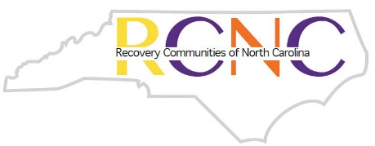
Recovery Communities of North Carolina

RECOVERY COACH ACADEMY & TRAINING OF TRAINERS

~APPLICATION~
Contact information:
- Name
- Mailing Address
- Phone number
- Email
If applicable, what organization do you work with:
Your role (volunteer/staff/intern):
Briefly describe your personal experience with addiction recovery:
Explain why you are interested in Recovery Coach training and how you will use it:
If applicable, please explain why your organization is interested in Recovery Coach training:
How will Recovery Coaching be used in the delivery of services?
In a few sentences, describe how your agency is well qualified to integrate the use of peer recovery coaches at this time.
Questions for Training of Trainers Applicants
Please describe your training qualifications and give examples of the trainings you have delivered:
Please describe how your organization will use your ability to train Recovery Coaches:
Please provide two references:
Reference 1
- Name
- Organization
- Phone number
- Email
Reference 2
- Name
- Organization
- Phone number
- Email

