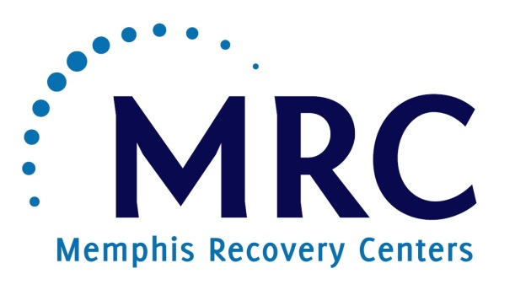
Various Positions

Looking for a rewarding career by helping individuals gain a life free from substance abuse?

Memphis Recovery Centers (MRC) provides professional counseling for youth and adults in a caring and confidential atmosphere. Throughout our history, we have stayed true to our mission...to return the individual to an adaptable level of spiritual, physical, social and occupational functioning, and to help each person and his/her family to begin a lifelong process of recovery.

MRC offers the following benefits: Medical Insurance Options, Life/LTD insurance, Company Matched 401k, and accrued PTO and Sick leave. All staff will gain training in CPR and CPI (Crisis Prevention).

Qualified applicants for all positions must meet the following requirements:
- Pass a criminal background check
- Have a valid driver’s license

Alcohol and Drug Counselor
This is a daytime shift or second shift position working with adults or adolescents. This position involves carrying a caseload, conducting lectures and groups, and transportation of clients using company vehicles in a residential environment.

Qualified applicants for Counselor must have a Bachelor's or Master’s degree in a Social Services field

Clinical Assistant/Program Monitor (2nd Shift and 3rd Shift-Overnight)
This position involves working with adolescent males, monitoring clients, and transportation of clients using company vehicles in a residential environment.

Qualified applicants for Clinical Assistant must have a High School Diploma or GED.

Program Manager (Adult Program)
This position's duties include, but are not limited to:
- Planning and developing substance abuse treatment
- Supervising and directing staff meetings
- Planning and delivering in-service training to clinical staff
- Establishing and maintaining clinical staff performance evaluation mechanisms
- Establishing and maintaining clinical program process and outcome evaluation mechanisms
- Acting as primary counselor as necessary
- Managing discharges and referrals
- Performing job duties with the overall efficacy of the agency as a twelve-step A&D addiction treatment facility as the salient consideration

Qualified applicants for Program Manager must meet the following requirements:
- Bachelor's in behavior science or human services field
- Master's Degree in behavior science or human services field in not required, but preferred
- Experience in a residential alcohol/drug Twelve-Step oriented treatment setting
- TN Licensed Alcohol and Drug Abuse Counselor (or letter of intent on file)

License Practical Nurse (LPN)
This position involves working with adults and adolescents in a residential environment.

Qualified applicants for Part/Full-time LPN must meet the following requirements:
- High School diploma or GED
- Licensed LPN

Maintenance Technician
This position involves minor repairs and general maintenance associated with a small business, as well as physically carrying a min. of 50 lbs. up three flights of stairs. We are currently offering a sign on bonus for this position until June 30th.

Qualified applicants for Maintenance Technician must have a High School Diploma or GED.

If you are interested in joining our team, please send resume to contact@memphisrecovery.com or apply online at www.memphisrecovery.com

