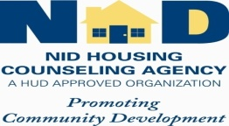 NOW REGISTERING! ®
WANT TO OWN A HOME?
Workshop follows HUD Approved Guidelines “Learn about State & City Down Payment Assistance & more!”
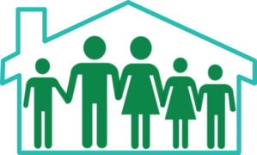 Free Workshop
Learn: How to get qualified for mortgage financing, Home Renovation, Down payment Assistance (“State of Illinois” offering up to $7,500) & more
Our information is understandable & easy to apply
Class begins 8:30 AM - Saturday, April 2, 2016
2012 E. 83rd Street, Chicago, IL 60617
Seating limited-Call for reservation: 773 429-8810
NID Housing Counseling Agency
(A HUD Approved Agency) E. J. Webber, Housing Counselor

