UNITED STATES COAST GUARD
CHIEF PETTY OFFICERS ASSOCIATION
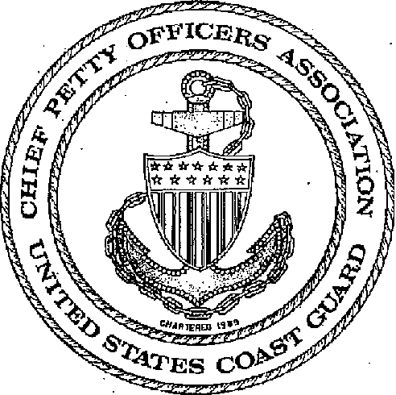
BY-LAWS
(21 August 2010)

Preamble
Ever mindful of:

*the traditions, duties, and purpose of the United States Coast Guard;
*our duty to uphold and defend the Constitution of the United States of America;
*our responsibility to assist and save distressed seamen and others;
*our responsibility in the enforcement of the laws of our country, and
*Believing that through Association and mutual acquaintance, the Chief Petty Officers of *the United States Coast Guard may:
*best advance their professional abilities;
*enhance their value, loyalty and devotion to God, Country and service in which they serve;
*promote its unity and morale, domestically and militarily, through responsible leadership.

"In respect for those who have gone before us And as a guide for those who follow. "

Purpose

The United States Coast Guard Chief Petty Officers Association is unique among service organizations in that it was created by the Chiefs, of the Chiefs, and for the Chiefs of the United States Coast Guard.

Ever mindful of:

*the traditions, duties and purpose of the United States Coast Guard;
*our duty to uphold and defend the Constitution of the United States of America;
*our responsibility to assist and save distressed seaman and others;
*our responsibility in the enforcement of the laws of our country, and

In believing that through Association and mutual acquaintance, the Chief Petty Officers of the United States Coast Guard may:

*best advance their professional abilities;
*enhance their value, loyalty and devotion to God, country and service in which they serve;
*promote its unity and morale, domestically and militarily, through responsible leadership;
*assist members and dependents in urgent need of assistance;
*assist in recruiting for the Coast Guard;
*support the aims and goals of the CPO Academy;
*assemble for social amenities;
*become involved in community affairs;
*promote social programs for those in need; and
*keep informed of Coast Guard matters.

CHANGES AND AMENDMENTS

CH # DATE CHANGE DATE ENTERED SIGNATURE

1 19August2011 20September2011 National VP
INDEX
SECTION TITLE Page #
I PARLIAMENTARY AUTHORITY 5
IIII GOVERNING BODY 5
III NATIONAL OFFICERS 5
IV ELECTION PROCEDURES 5
V MEETINGS 5
VI EXECUTIVE DIRECTOR 6
VII ORGANIZATION 6
VIII DISCIPLINE & JURISDICTION 8
IX AMENDMENTS & REVISION 8

BY-LAWS
SECTION I
Parliamentary Authority
- Roberts Rules of Order shall be the Parliamentary Authority.
- The President's Call to Convention shall designate the revision to be used.
- The President shall appoint a Parliamentarian.
SECTION II
Governing Body
1. The Organization shall have a Governing Body called the National Board of Directors, consisting of the National Officers and three Regional Advisors.
SECTION III
National Officers
1. The National Officers shall consist of the President, Vice President, Secretary, and Treasurer.
SECTION IV
Elections
- The Association shall hold elections.
- A member of the Association may only compete for one National officer or Regional Advisor position during any given National CPOA Election.
- A member of the Association who has served in the position of National President for two terms, either consecutively or non-consecutively, will not be eligible to serve as National President again.

SECTION V
Meetings
1. The Association shall hold an Annual Meeting or Convention each year.

SECTION VI
Executive Director (ED)
1. The Association shall have a salaried Executive Director.
SECTION VII
Organization
1. Membership

a. Regular membership —All persons who have successfully held the rank of Chief Petty Officer in the United States Coast Guard. (Eligibility is effective the date of advancement or frocking). A member in Good Standing is a Gold or Silver Lifetime Member, or is a Regular member who is paying the current dues established by the BOD.

b. Associate Membership — All persons who have successfully held the rank of E-7 in any of the other United States Armed Forces. Associate members shall not hold any elective office.

c. Honorary Membership — Persons not eligible for membership, who have rendered distinguished service to the Association may be awarded an honorary membership. Honorary members shall not be eligible to hold office, vote, or pay membership dues.
National honorary membership nominations may be submitted to the BOD.
Chapters may award honorary memberships.

d. Silver Lifetime Membership — Any Regular or Associate Member may purchase a Silver Lifetime membership. A Silver Lifetime Fund is established to provide a financial account where interest generated would provide the dues for members who purchased this membership. The interest only from this fund will be transferred, as accrued, to the general organization funds. The interest amount will be used to offset the annual budget. Members who purchase Silver Lifetime Membership will not be authorized a return of their funds for any reason.

e. Gold Lifetime Membership — Any E-7, E-8 or E-9 (Regular Member) who has rendered distinguished and tangible service in a exemplary and outstanding manner as to promote and advance the welfare of fellow members, their dependents or their Community/Country may be awarded a Gold Lifetime Membership. Gold Lifetime Members shall not be assessed dues.

(1) Nominations shall be submitted in resolution format to the Gold Lifetime Membership Selection Committee via the National Office 120 days prior to a National Convention.

(2) The Gold Lifetime Membership Selection Committee shall be a committee of the Whole which may select a maximum of two Gold Lifetime memberships during an Association year.
2. Dues
a. The Association shall have dues.
3. Chapters
a. The Association shall have Chapters.
4. Committees
a. The Association shall have National Standing Committees.
5. Funds
a. The Association shall have funds.
6. Units and Branches
a. The USCG CPOA Auxiliary (CPOAA) and USCG Enlisted Association (CGEA) are constituent organizations of this Association and shall be governed by the same guidelines and restrictions.
7. Awards
a. The Association shall have awards.
SECTION VIII
Discipline and Jurisdiction
1. The Board of Directors shall have jurisdiction over the General Membership of the Association to include National Officers and Board Members, and shall be governed by current Parliamentary Authority. All disciplinary actions of the Board of Directors are subject to ratification of the Convention Delegation. The Board of Directors shall report all disciplinary actions taken each year to the Annual Convention.
2. In the unfortunate event of a trial, removal from office or revocation of membership should become necessary it shall be conducted in accordance with current Parliamentary Authority, both leading up to and including the specific process itself, Trials, Removal from Office and Revocation of Membership shall be held during Annual Convention. The National Board of Directors shall take all necessary action in the event of illegal activity by a National Officer, Board of Director member or the General Membership, subject to ratification by the members in attendance at the subsequent Annual Convention.
3. A member has the right of appeal to any action. Rulings on appeals shall be by action of the Annual Convention.
4. Members are expected to maintain their conduct so as not to discredit the Coast Guard or the Association.
SECTION IX
Amendments and Revisions to the By-Laws
1. The By-Laws shall be amended by Resolution and approved by the membership at the annual CPOA Convention.

Change 1: 2011 National Board of Directors Resolution No.1
Change 1: 43rd National CPOA Convention Minutes - By-Laws Convention Committee Report (Encl 19)
Change 1: 43rd National CPOA Convention Minutes - By-Laws Convention Committee Report (Encl 19)
Change 1: 2011 National Board of Directors Resolution No.2
Change 1: 2011 National Board of Directors Resolution No.3
Change 1: 2011 National Board of Directors Resolution No.4
Change 1: 2011 National Board of Directors Resolution No.5
Change 1: 2011 National Board of Directors Resolution No.6
Change 1: 2011 National Board of Directors Resolution No.7

