Backpacks for Kids
A Community-Wide campaign to provide low income and struggling students with the school supplies they need to start the school year prepared to learn.
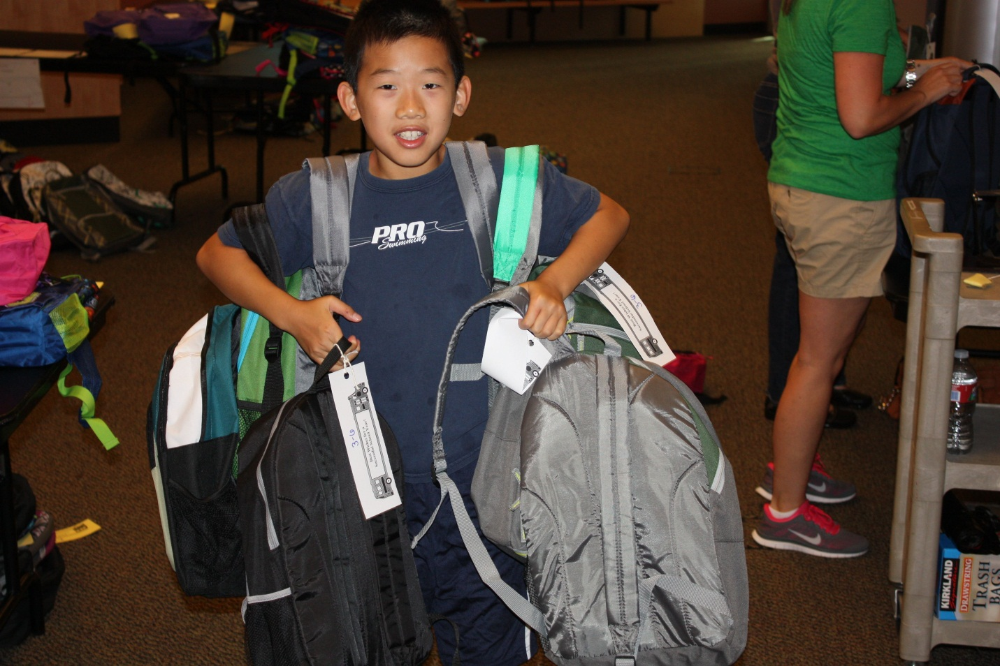
Northshore School District's 15th annual Backpacks for Kids campaign begins July 9.
The multi-week campaign benefits local families who are unable to send their children to school with necessary school supplies. Last year we provided more than 1100 backpacks. This year the need is even greater.
This year's campaign will run July 9 to August 30. During these dates your business can volunteer to be collection sites or you can form an office work party to support the assembly process.
Be a collections site: Sign up by June 30th to be a collection site. Contact us here: SchoolsFoundation@nsd.org
Volunteer: Sign up to volunteer at http://vols.pt/A6J3kA
Supplies we are seeking:
- new, sturdy backpack
- color pencils
- #2 lead pencils
- markers (wide tip)
- 2 inch 3-ring binder
- highlighter
- eraser/eraser tops
- 12 inch ruler
- scissors (blunt and pointed tip)
- pencil pouch
- glue sticks
- pocket folder/Pee Chee (no metal clasps please)
- blue/black pens
- notebook paper (college and wide rule)
- red ink pen
- spiral notebook (college and wide rule)

Backpacks for Kids is one more way Northshore is working to Strengthen Our Community Through Excellence in Education by providing students the opportunity to start the school year prepared to learn. This project is now being coordinated in partnership with the Northshore School District and the Northshore Schools Foundation.
For more information contact:
Carmin Dalziel, Northshore Schools Foundation schoolsfoundation@nsd.org. 425 408 7680
