Donna Goodell, Program Director
Pre-school, Elementary & Middle School Programs

James Kelly, Program Director
High School Programs

Patric Barbieri
Executive Director

Maria Giangrande
Administrative Assistant

August 11, 2015
Dear Parents and Guardians of students in LABBB’s Belmont High School Program:
I hope this letter finds you well and enjoying the wonderful August weather with family and friends. At the end of this school year, we had some changes to our administrative team as people decided to retire or take on other roles. We also had some changes in our team of Vocational Counselors. In response to these changes, we have hired new coordinators and counselors and reorganized oversight responsibilities a little.
I want to take this opportunity to let you know who the Coordinator and Vocational Counselor will be for your child. James (Skip) Avery is the Coordinator and will be working with you and your educational team. Skip received his Master’s Degree in special education from Fitchburg State College. He began his career as a special education teacher at LABBB where he taught high school students for 5 years. After leaving LABBB, he was a middle school teacher at Carlisle Public Schools for 5 years, then moved to the Winchester Public Schools where he spent the last 9 years as a lead teacher and special education supervisor in an elementary school. Skip is excited to be returning to LABBB.
Amanda O’Leary will be the Vocational Counselor working with your child. Amanda was a teacher in our LABBB high school programs for four years, then a vocational instructor at our various job sites for nine years. Last year, Amanda joined our team of vocational counselors and has been an outstanding member of this team.

We hope that you will attend our open house in September so you can meet the new members of your LABBB team in person. You will receive more specific information about the open house date and time soon. We hope you enjoy the rest of the summer vacation and look forward to seeing everyone in September.
Sincerely,
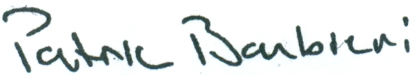
Patric Barbieri
Executive Director

