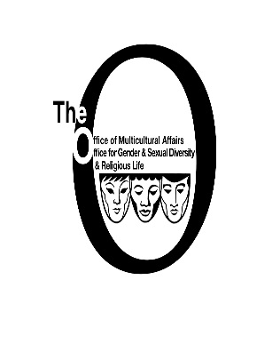
2015-16 OMA Internships
The Office of Multicultural Affairs is now seeking graduate and undergraduate interns for the summer, fall and/or spring 2015/16 academic year. The internship program is unpaid. However, you will receive credit toward your degree and gain valuable experience working with our office and staff. Depending on your skills and interests you will have an opportunity to conduct research, develop and assist in facilitating cultural competency/ diversity training modules and gain valuable experience in program planning, marketing, and assessment. Your work will play a key role in furthering efforts to support students of color on campus. Success in this internship will depend on your ability to be a self- starter, detail oriented, creative, caring and responsible, with good communications skills. If you are interested, please answer the following questions and submit them during the internship fair, or in “The O” located in the basement of the LBC or via email pierre@tulane.edu, by April 10, 2015. You will be contacted for an interview by April 13, 2015.
Name:_______________________________________________________________________
Current Year in School_________________________________________________________
Email:_______________________________________________________________________
Phone:______________________________________________________________________
Semester- You are seeking an internship for: ___ Summer ___Fall ___Spring
Please indicate your project preference Rank your preference (1-4 with 1 being your first choice)
______Research _______Program Planning ______Training Modules Development
______ Assessment

Return To: Carolyn Barber Pierre
Office of Multicultural Affairs
Suite G04, Lavin Bernick Center
504- 865-5181

