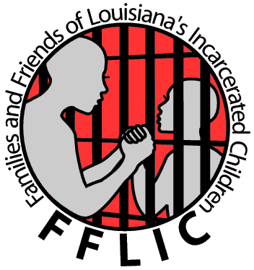

Families and Friends of Louisiana’s Incarcerated Children (FFLIC) is seeking an
Communications and Development Intern

FFLIC is a statewide membership based organization dedicated to creating a better life for all of Louisiana’s youth especially those who are involved or at risk of getting involved with the juvenile justice system. We use the strategies of education, peer advocacy and direct action organizing to build strong, powerful families and communities and to fight for justice for our children and ourselves. We specifically seek to transform the education and juvenile justice systems and ensure that resources move from incarceration and punishment to community based programs and educational opportunities that help youth and families grow and thrive.

Development
- Assist executive director with raising budget
- Research foundations accepting proposals
- Create and maintain outlook calendar for fundraising dates and deadlines
- Record foundation grants
- Update fundraising tracking grid
- Write thank yous for donations and grants
- Research and assist in creating development plan with Executive Director
- Tracking membership

Communication
- Develop brochures with program personnel on specific programs
- Assist in website design and maintenance
- Gather input from individuals for doing overhauls to website
- Ensure data integrity is restored through phone lists being checked and updated
- Make desk book for how to do things in database
- Assist in newsletter development
- Create other marketing and programmatic material on an as needed basis

