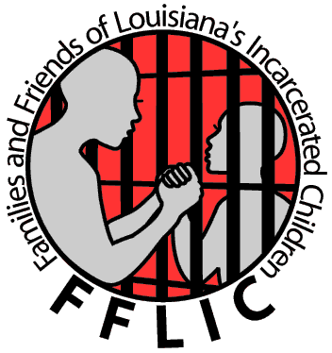
Families and Friends of Louisiana’s Incarcerated Children (FFLIC) is seeking a
Community Outreach Intern

FFLIC is a statewide membership based organization dedicated to creating a better life for all of Louisiana’s youth especially those who are involved or at risk of getting involved with the juvenile justice system. We use the strategies of education, peer advocacy and direct action organizing to build strong, powerful families and communities and to fight for justice for our children and ourselves. We specifically seek to transform the juvenile justice system, the education discipline policies and ensure that resources move from incarceration and punishment to community based programs that help youth and families grow and thrive.

The Interns job would include:

Outreach and recruitment:
- Assisting in regular outreach and recruitment of new FFLIC members in order to build a strong FFLIC chapter and data basing contacts and new members by following the all the organizing protocols in our 4 chapters – (New Orleans, Lafayette, Lake Charles and Shreveport);
- Develop any needed outreach materials with staff;
- Advocacy with parents and families struggling with a child in the juvenile justice and school systems by following advocacy protocols and ensuring all information is databased for story circle and reporting needs across the state;

Community Building and Membership Development:
- Working with designated staff to coordinate Leadership Development and Community Building Leadership with members to develop peer advocates and community leaders and ensuring all attendance to trainings and database;

Taking Action and Confronting Power:
- Assistance in coordinating local campaigns that empowers members to transform the juvenile justice system, transform the local school systems, demand quality community based programs and opportunities and develop other local campaigns and the membership deems necessary that stays with the FFLIC vision and mission
- Assistance in coordinating statewide campaigns with members designated staff and making sure members are present and prepped for any direct actions

Organizational Management:
- Follow all organizational management protocol
- Other duties as assigned
- Creation of outreach materials
- Assistance with social media

