SAVE THE DATE!!  COLORADO AREA ROUND TABLE EVENT  When:  APRIL 30TH, 2016  10am – 2pm  WHERE:  DoubleTree by Hilton Hotel Denver-Thornton  83 East 120th Avenue, Thornton CO 80233  What:  INFORMATIONAL SESSION LED BY JETT FOUNDATION STAFF WITH PARTICIPANTS FROM DUCHENNE FOCUSED COMPANY PARTNERS  CLINICAL TRIALS ~RESEARCH IN THE PIPELINE~  *. |  |  | HOSTED BY  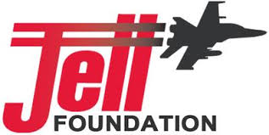  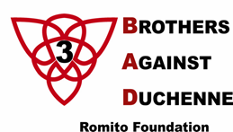  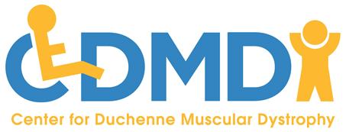NO COST TO ATTEND  Lunch provided  Email Jenn To register  jennmc@jettfoundation.org

