SEMINAR DATE, TIME & LOCATION:

February 4, 2016 – 8:00 AM to 4:30 PM – Hickory, NC

Location of Seminar: ***Courtyard by Marriott, 1946 13th Ave. Drive SE, Hickory, NC***

**Date & Time:** February 4, 2016, 8:00 AM – 4:30 PM

Tuition - BMSA members: **$289** for first employee from Company

**$260** for each additional employee

**Nonmember Tuition: $489** each employee of nonmember company

*Tuition includes seminar instruction and all handout materials. Transportation, meals, lodging & incidental expenses are not included.*

**Lodging:** Courtyard by Marriott; 1946 13th Avenue Drive SE, Hickory, NC 28602; 828.267.2100; Room Rate: $129. Be sure to tell the hotel you are part of the Building Material Suppliers Association group for this special rate.

***NEW SEMINAR! AS REQUESTED!!***

**Advanced Estimating**

**& Material Take-off**

**In conjunction with**

***BMSA’s Building Products Show***

**February 4, 2016 – 8:00 AM – 4:30 PM**

***Hickory, NC***



**After receiving many requests, Casey Voorhees has developed an Advanced Estimating Course designed to provide a deeper understanding of residential framing as well as increased efficiency in completing material estimates. This workshop will go beyond basic house design and focus on the difficult areas of completing framing take-offs.**

**Topics Covered:**

* Irregular floor and roof layouts
* Daylight (walk-out) basements
* Margins, board footage, price conversions
* Stick-framed roofs including hips, valleys and jack rafters
* Multi-pitched roofs
* Vaulted walls and ceilings, rake framing

**Who should attend?**

Those attending the 2-Day Introduction to Material Take-Off workshop may continue with this course. If registering for this session only, please be sure your personnel have the requisite experience and are familiar with interpreting plans, residential construction methods and fundamental material take-off concepts. **This is an Advanced Course**.

**Instructor:**

Casey Voorhees has over 35 years of experience in the building material industry including over 20 years teaching contractor sales and material take-off.

***Note:******Plan on arriving early on February 3rd and join us for BMSA’s Building Products Show directly across from the hotel at the Hickory Metro Convention Center where you’ll see all the latest in products and services for the building industry! There’s no charge and you’ll learn a lot from seeing all the new products and services available!!***

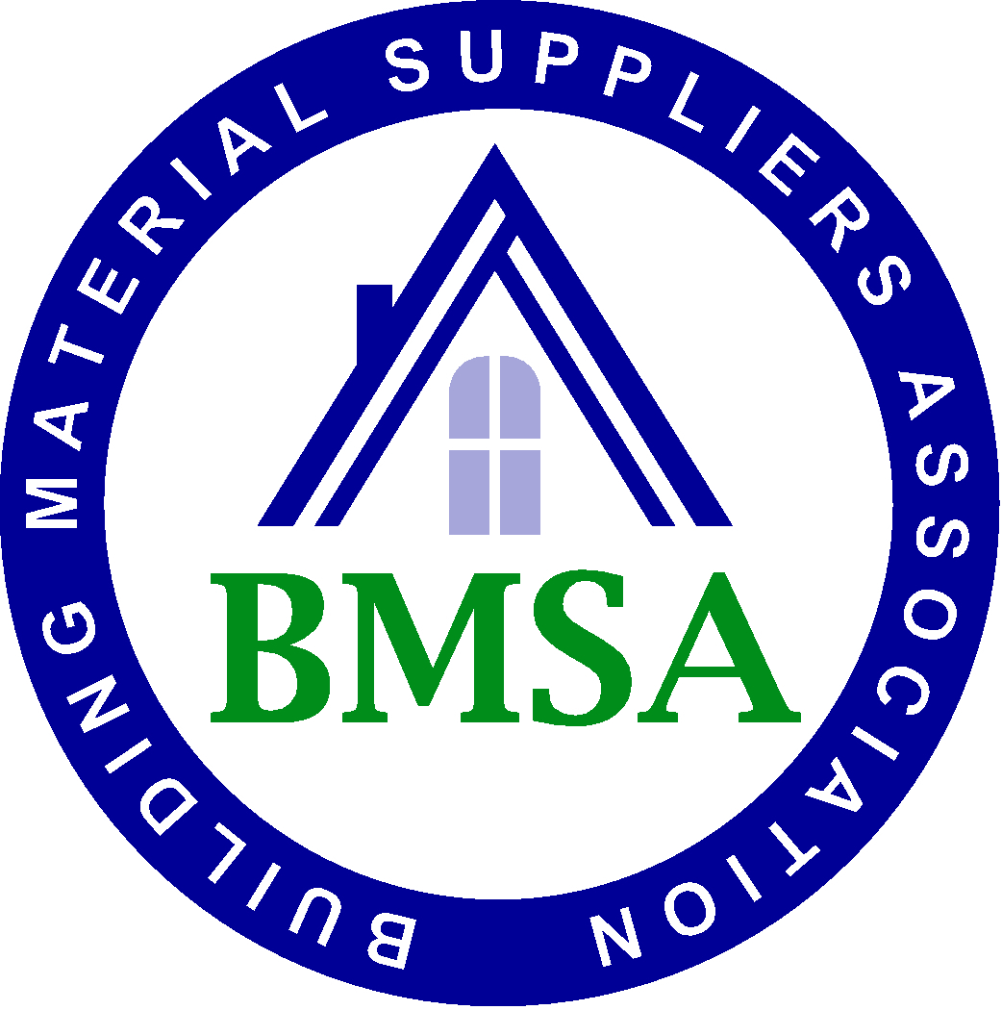

Please Register

the Following People:

________________________________________________________________________________________________________________________

Company Information (please print)

________________________________________

Company Name

______________________________________________Contact Name

______________________________________________

Address

______________________________________________

City/State/Zip

______________________________________________

Telephone

______________________________________________

Fax

______________________________________________

E-mail

To register please complete & fax to: **704.331.9663** or email to: janeg@mybmsa.org

***Questions? Phone: 800.966.4202***

Payment Options:

 Check Enclosed  MasterCard

 VISA  AMEX

 Bill Us (Members Only)

Card # _________________________________________

Name on Card

_________________________________________

Card Holder Billing Address & Zip Code

_________________________________________

Security # _______Exp. Date: ___________/_____

**Checks should be sent to BMSA at: PO Box 18667, Charlotte, NC 28218**

**Cancellation Policy:** *Any cancellation must be received 20 business days prior to the seminar. After noon on* ***January 7, 2016*** *charges are due regardless of attendance. Substitutions may be made at any time.*