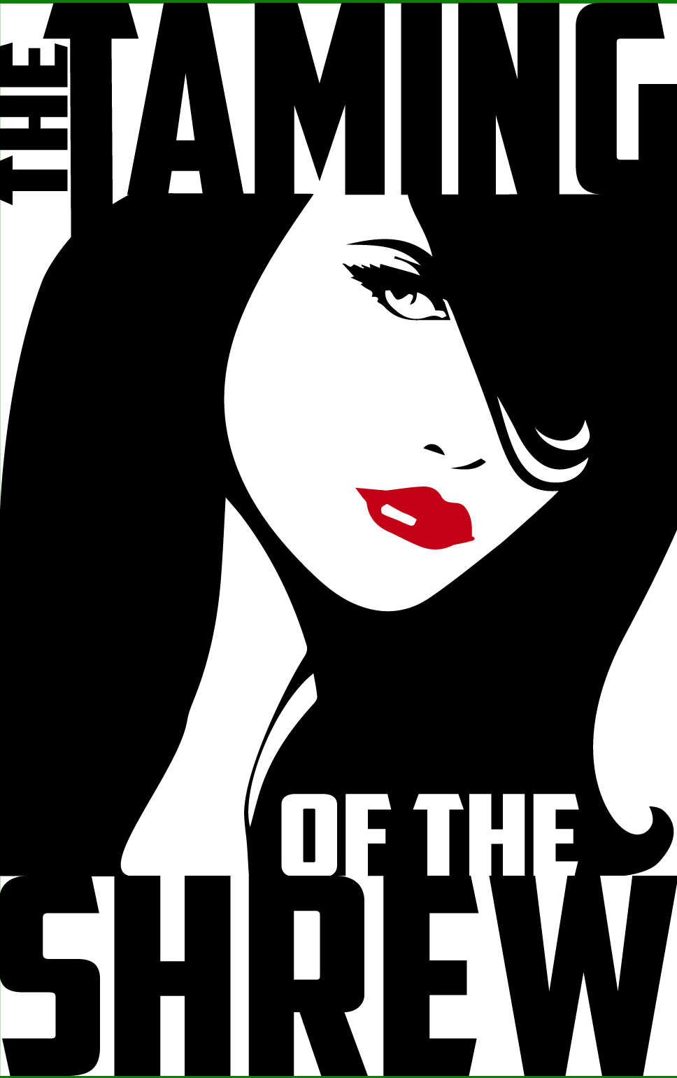
TICKET PRICES:

Adults - $10
Students (19 years and younger) and
Seniors (62 years and older) — $8

Tickets available at: http://www.stogatheatre.com

Produced by special arrangement with Playscripts, Inc.
(www.playscripts.com)
SHOW DATES:

Thursday, November 19 - 7:00 PM
Friday, November 20 - 7:00 PM
Saturday November 21 - 2:00 PM and 7:00 PM

Conestoga High School
Hobson C. Wagner Auditorium
Stoga Theatre presents…

The Shakespeare comedy, Taming of the Shrew

Come join us in Padua as Petruchio tames the fiery shrew known as Katherine. Travel back to 1950's Italy where you will find a wealthy father who is trying to marry off his eldest daughter so the youngest daughter can get married to one of her many suitors.

In Shakespeare's classic comedy, be prepared for confusion, disguises, physical comedy, and even a few witty puns. Come find out if Petruchio has the bravado to best the "untameable" Katherine.

Directed by: Natalie Gaspari

