

**Please Donate!**

2015



**Supplies Needed:**

**BACKPACKS CRAYONS PENCILS**

**BINDERS ERASERS PENCIL SHARPENERS**

**CALCULATORS GLUE STICKS PENS**

**COLORED PENCILS HIGHLIGHTERS POCKET-FOLDERS**

**COMPASSES INDEX CARDS PROTRACTORS**

**COMPOSITION BOOKS LOOSE LEAF PAPER RULERS**

**MARKERS SCISSORS**

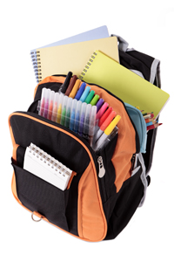[](http://www.addressthehomeless.org/)

Host a drive in your community, school, office or congregation.

Drives are running now through Friday, August 14th.

Please contact (Insert Name) at (Insert Phone Number) or

(Insert Email)