**St. Mary’s School Board Elections-please circle three names**

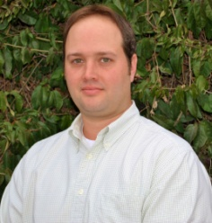**Kyle Kiehne -**  I was born and raised in Fredericksburg, attended St. Mary’s School from Kindergarten through 8th grade and earned my B.A. from U.T. San Antonio. I have been married to Casie Staudt-Kiehne since 2005. Our daughters, Kenley (1st grade) and Peyton (4k), are 4th generation St. Mary’s School students and 2nd generation visitors of Mr. Pahl’s office. A little more than 2 years ago Casie and I decided to take a leap of faith and return to Fredericksburg as we couldn’t imagine our girls growing up anywhere else. This has been the best decision and we are all very happy and proud to call Fredericksburg and St. Mary’s home again. Since getting back I have joined Optimist Club of Fredericksburg, where I serve as a Director, am a member of Gillespie County Leadership class 2016 and volunteer at school functions as much as I am able to. I work as a REALTOR® with the Real Estate Advisory Team and Casie is employed as a Dental Hygienist at Fredericksburg Dentistry. I am excited to be a part of the St. Mary’s School council and look forward to making myself available to listen to the school community and to help ensure that St. Mary’s School is the best that it can be.

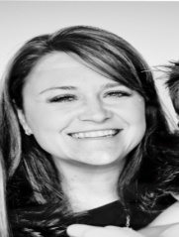**Jay Tewksbury -**  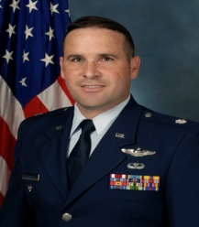I am married to Katie Tewksbury and we have two sons (John and Jacob) and a daughter (Ann Marie) who attend St. Mary’s School.  Katie and the kids initially moved to Fredericksburg in 2013 to be closer to family while I was deployed for a year to Afghanistan.  By the time my deployment was ending they had all come to love St. Mary’s and the Fredericksburg community, so instead of returning to Colorado we decided to retire here and start a new chapter of our lives.  We served a little over 23 years in the Air Force; the majority of that time spent in helicopter operations.  I also had the opportunity to teach at the Air Force Academy, serve as the Director of Leadership Programs for the Dean and the Director of Operations for the Commandant of Cadets.  I have an MS in Computer Systems Management, an MA in Education Counseling and Leadership, and a BS in Behavioral Science from the Academy.  My family and I are very happy to be in Fredericksburg and look forward to serving the students and parents of St. Mary’s School.

**DeDe Threadgill** - I have been a member of St. Mary's Church & School  community for 14 years. I am  proud that all of my children, Bailey (2010), Riggs (2014), Della 6th grade, and Drake 4th grade have continued the legacy of Catholic education I learned from my parents and grandparents.    St. Mary's has given me many opportunities to volunteer, including being a chairperson on the annual Mardi Gras Gala. I am a member of ACTS and have served as an assistant director. St. Mary's is a community that thrives on families giving back, and I have been happy to help in many capacities over the years. I am a small business owner of The Vintage Cellar, a wine tasting room at Rocky Hill. I would appreciate the opportunity to serve on St. Mary's School Council. The next few years will be an exciting time in our school. I would like to be able to contribute the future growth academically and spiritually, while cherishing the traditions that St. Mary's was built on.

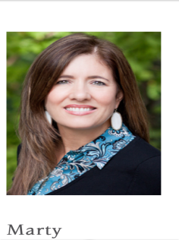**Marty Harkleroad** - My husband Bill and I moved here from San Antonio in 2010. One of the best decisions we made when we moved here six years ago was putting our two children, Ryann (10th grade) and Luke (3rd grade), here at Saint Mary's. It has had such a positive effect on all of our lives. Bill and I own Kino Oil here in Fredericksburg and I am a dental hygienist with Lance and Heidi Kovar. In addition to volunteering and helping on various committees here at Saint Mary's, I am also Vice President of the high school Billie Parent Organization. I would be honored to help ensure the continued success of this great school and support the rich history of Saint Mary's by being dedicated to doing what is best for our children, ensuring they have a quality education and preparing them for meaningful, successful lives.

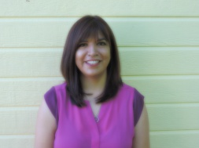

**Mary Llanes Guevara -** I am originally from South Texas. My husband Reyes, a Fredericksburg native, and I were married at St. Mary’s Catholic Church and both our children Diego, 3rd grade, and Demi, 1st grade, attend St. Mary’s Catholic School. Fredericksburg has been my home for 17 years. I am a graduate of Schreiner University with a BA in History and Masters of Business Administration. I am currently the Senior Director of Business Development at Fischer & Wieser Specialty Foods, Inc. Sending our children to St. Mary’s Catholic School has been a wonderful blessing. The St. Mary’s family has been an integral part of our lives and I look forward to the opportunity to give back to the school and community we love.