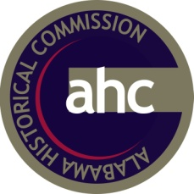
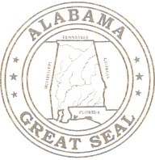
STATE OF ALABAMA
Lisa D. Jones, Acting Executive Director

www.preserveala.org

STATE OF ALABAMA
ALABAMA HISTORICAL COMMISSION
468 SOUTH PERRY STREET
MONTGOMERY, ALABAMA 36130

ALABAMA HISTORICAL COMMISSION
SOUTH PERRY STREET
MONTGOMERY, ALABAMA 36130
334-242-3184

FOR IMMEDIATE RELEASE:
October 23, 2015

The Alabama Historical Commission will hold the annual Frontier Days at Fort Toulouse – Fort Jack Park on Wednesday, November 4 through Saturday, November 7, 2015, from 9:00 AM to 4:00 PM. Admission will be charged.

This annual educational event will feature demonstrations and activities that illustrate what life was like as the south transitioned from Creek Indian lands to military forts and civilian homesteads in the eighteenth and nineteenth centuries.

Demonstrations for visitors will include blacksmithing, musket firing, period food vendors, Native American archery and blowguns, and much more!

“This popular event provides an opportunity for the public to have an up-close view of what life was like when Alabama was part of the southern frontier of the United States,” said Lisa D. Jones, Acting Executive Director of the Alabama Historical Commission. “Attendance to Frontier Days continues to grow each year which directly reflects the Alabama Historical Commission’s talented, dedicated staff, the strong support of the Commission, Friends organizations, and visitors to our historic sites.”

"This is the largest history-based education event in Alabama,” said Ove Jensen, Site Director of Fort Toulouse-Fort Jackson Park. “It also happens to be one of the most colorful events with the uniforms and clothing of the 1700s and early 1800s that are worn by re-enactors throughout the park."

Payment is accepted in the form of cash, checks and credit cards.
Reservations are requested for school groups on November 4-6.
Fort Toulouse – Fort Jackson Park is located at 2521 W. Fort Toulouse Road, Wetumpka, Alabama.

For more information about Frontier Days, contact the Fort at 334.567.3002 or visit fttoulousejackson.org.

Located in historic downtown Montgomery at 468 S. Perry Street, the Alabama Historical Commission is the historic preservation agency for the state of Alabama. The agency was created by an act of the state legislature in 1966 with a mission of safeguarding Alabama’s historic buildings and sites. The Commission is tasked with the acquisition and preservation of historic properties and education of the public about historic sites in Alabama. Visit http://preserveala.org/ for a complete list of historic sites and for office hours.

###

