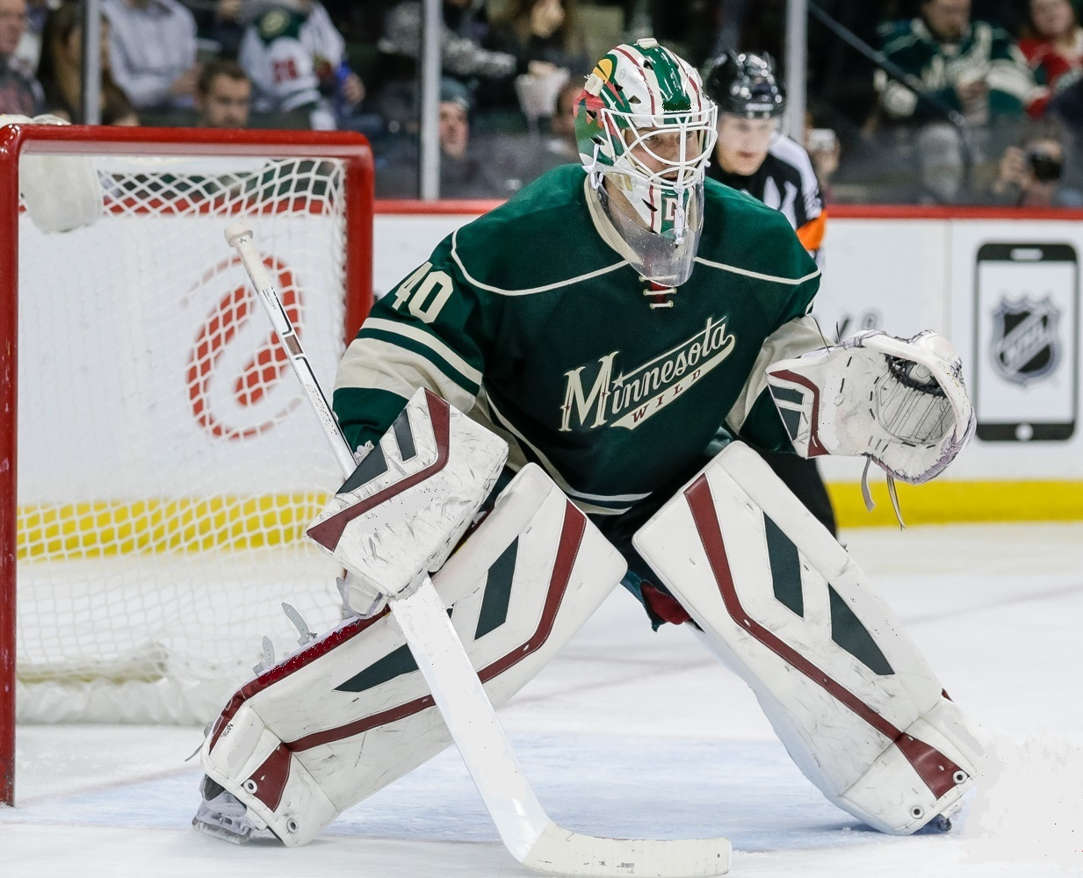 Devan Dubnyk - student since 2000

What We Teach
Eli Wilson Goaltending teaches a cutting edge style. The main focus is to make goaltenders more efficient so they can be more effective. We use game situation movements in high repetition to teach goaltenders how to move correctly, under control and with balance. Students learn where to be, how to get there quickly, how to make consistent saves and how to control rebounds. The key to effective goaltending is simplicity. The simpler the game you play, the more often you will be in a position to make saves and improve save percentage and goals against average
Requirements: Goaltenders that have a strong work ethic and have a strong desire to learn and improve.
Benefits: We teach a system that is a foundation to build upon and develop.
Outcomes: Goaltenders that learn our system for the first time make quantum leaps in their performance and levels of play. Teaching a compact butterfly style combined with read and react skills creates the ultimate hybrid goaltender.
Eli Wilson is recognized as one of the best Goalie Coaches in the World. He has 30 students that have played in the NHL. Eli teaches elite goalies in the NHL, KHL, AHL, WHL, OHL, QMJHL and NCAA.
WHATEVER YOUR LEVEL, ELI WILSON GOALTENDING WILL MAKE YOU BETTER

Eli Wilson Alumni

NHL & KHL
Carey Price (Montreal Canadiens)
Tuukka Rask (Boston Bruins)
Devan Dubnyk (Minnesota Wild)
Tim Thomas (Dallas Stars)
Ray Emery (Philadelphia Flyers)
Brian Elliott (St. Louis Blues)
Cory Schneider (New Jersey Devils)
James Reimer (Toronto Maple Leafs)
Chris Mason (Nashville Preditors)
Jeff Glass (Dinamo Minsk - KHL)
Jason LaBarbera (Philadelphia Flyers)
Curtis McElhinny (Columbus Blue Jackets)
Chad Johnson (Buffalo Sabres)
Robin Lehner (Buffalo Sabres)
Justin Peters (Washington Capitals)
Leyland Irving (Calgary Flames)
Martin Gerber (Edmonton Oilers)
Nathan Lawson (Ottawa Senators)
Alex Auld (Ottawa Senators)
Cody Rudkowsky (St Louis Blues)
Andy Chiodo (Pittsburgh Penguins)
Brian Finley (Boston Bruins)
Mike Brodeur (Ottawa Senators)
Matt Keetley (Calgary Flames)
Kevin Weekes (New Jersey Devils)
Pascal Leclaire (Ottawa Senators)
Mackenzie Skapski (New York Rangers)
Malcolm Subban (Boston Bruins)
Chris Holt (Donbass HC - KHL)
AHL & ECHL
Michael Houser (Ontario Reign)
CJ Motte (Elmira Jackals)
Joey MacDonald (Hamilton Bulldogs)
Thomas McCollum (Grand Rapids Griffins)
Eric Comrie (Manitoba Moose)
Daniel Altshuller (Charlotte Checkers)
Josh Robinson (Missouri Mavericks)
Igor Bobkov (Utah Grizzlies)
James Reid (Evansville Icemen)
Jacob DeSerres (Colorado Eagles)
Major Junior
Payton Lee (Edmonton Oil Kings – WHL)
Coleman Vollrath (Victoria Royals – WHL)
Griffen Outhouse (Victoria Royals – WHL)
Cody Porter (Calgary Hitmen – WHL)
Stuart Skinner (Lethbridge Hurricanes – WHL)
Ryan Kubic (Vancouver Giants – WHL)
2016 Camp Dates
DETROIT- June 20-24 in GROSSE POINTE
Denver – June 27- July 1 at Big Bear Arena
Toronto Elite Prospect - July 3-8
Toronto – July 10 - 14 at Powerade Centre
Edmonton Elite Prospect - July 17 – 22
Edmonton 1 – July 25 – 29 at Spruce Grove
Calgary – August 1 – 5 at Hartman Sportplex
Saskatoon – August 8 – 12 at Legends Arena
Edmonton 2 - Aug 15 – 19 at Spruce Grove
Kelowna – August 22 – 26 at Summerland
Kelowna – Pro Camp (August 22 - 26)
All Camps $995 plus tax where applicable (except Elite Prospect camps by invite only $3,295)
To book Detroit - Call 313-610-7700 or email cwpiku@gmail.com for more information.
To book all other locations - Call 780 443-3014 or e-mail: info@eliwilsongoaltending.com
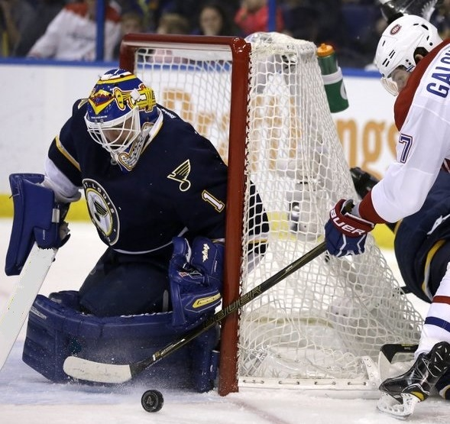
Brian Elliott – student since 2007

Camp Outline
Group 1 Group 2
Check-In 1^{rst} Day 8:15 AM 10:15 AM
On Ice 9:00 – 10:50 11:00-12:50
Dryland 11:30 – 12:30 ----------------
Lunch 1:00 – 1:30 1:00 – 1:30
Classroom 1:30 – 2:00 1:30 – 2:00
Dryland ---------------- 2:15 – 3:15
On Ice 2:30 –3:50 PM 4:00 – 5:20 PM

Times may vary slightly at each location Camp
Schedules and Availability are Subject to Change

Pro Camp - Kelowna, BC (August 22-26)
- $500. per day
- 2 hours of ice per day
- NHL AHL ECHL shooters
- Goaltenders with NHL contracts only
- Must submit video before attending
- All goaltenders must arrive in top shape, unlimited phone and video support will be available throughout
the next season (2016-17)

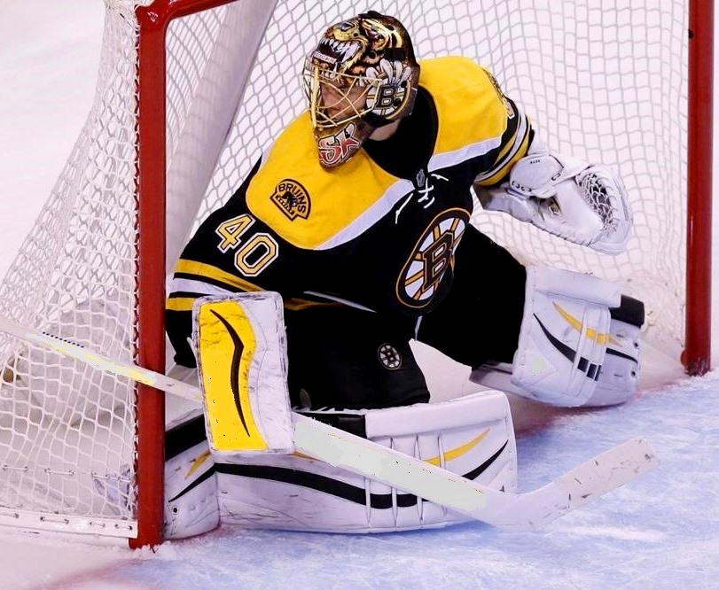
Tukka Rask – student since 2006

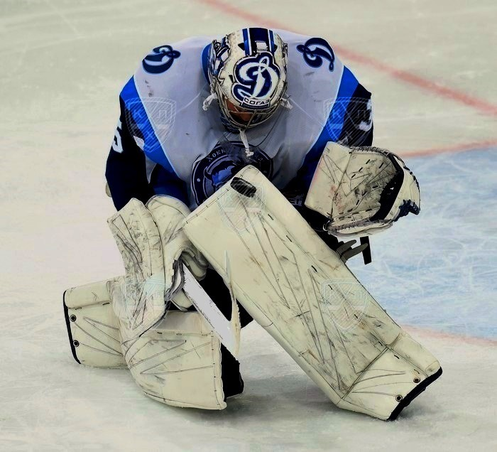
Jeff Glass – student since 2001

Camp Registration
Detroit: Chris Piku ph: 313- 610-7700 e-mail: cwpiku@gmail.com

All other locations: Dan Meyer

ph: 780-443-3014
e-mail: dan@eliwilsongoaltending.com
_____________________________________________
Payment Method ($995. US total)
(3 payment plan available)

Pay with Checque, Visa, Mastercard, Discover
Cancellation Policy Refunds are only available for cancellations before April 1st. All cancellation after April 1st and up to 30 days prior to start of camp will receive a voucher . No vouchers for cancellation 30 days prior to camp start unless a doctor note provided for illness or injury. (All refunds and vouchers will be less a $100 administration fee.)
Visit our websites at:
www.eliwilsongoaltending.com
www.pikuworldpro.com

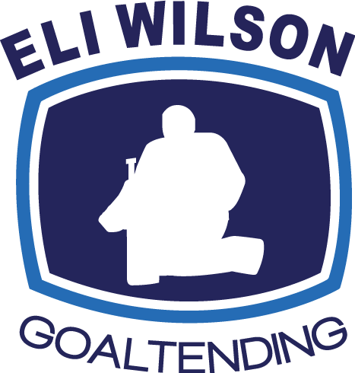
2016 Goaltending

Camps
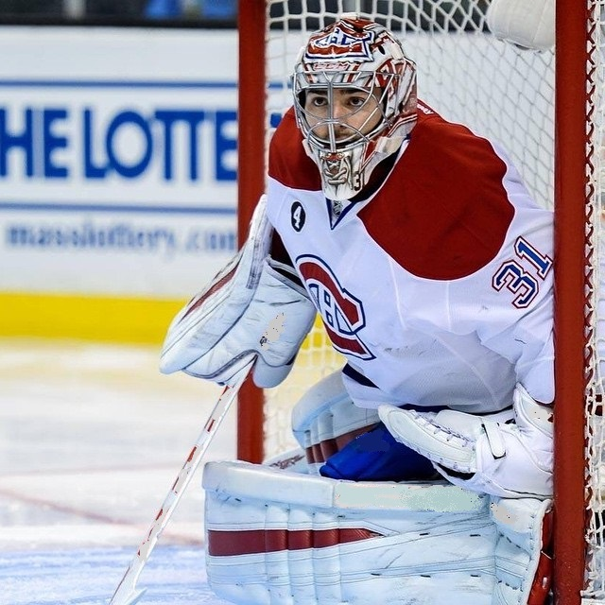 Carey Price – student since 2006


313-610-7700

