The Season of Lent 2016: First United Methodist Church, Cary
Forgiveness. The first word Jesus speaks from the cross is one of forgiveness.
A famous singer proclaims, “I think it’s about forgiveness, even if you don’t love me anymore.” But what is forgiveness? How do we receive it? Who must we forgive – others, ourselves? And what is this “forgive and forget” business when I have been so badly hurt? During the Lenten season, as we approach God’s ultimate act of forgiveness on the cross, we will explore together what forgiveness means for our spiritual journey and life of discipleship.
First, here is a brief outline of the sermon series so you may follow along:
February 14, 1st Sunday in Lent: Psalm 32; Luke 23:32-37
Perhaps the most powerful words in the English language are “I forgive you.” How much more powerful they are when God speaks them. Week one, we will explore God’s forgiveness of human sin and of my sin specifically.

February 21, 2nd Sunday in Lent: Psalm 32:1-5; 1 John 1:5-10; Luke 5:1-10
We say confession is good for the soul. It is a necessary aspect of receiving forgiveness. Until
we can acknowledge that we have done something wrong, we cannot recognize that we need
to be forgiven. Once we confess, however, we can receive pardon and mercy.

February 28, 3rd Sunday in Lent: Colossians 3:12-15; Matthew 6:7-13
When we pray the Lord’s Prayer, we pray that we will be forgiven as we forgive others. What is
the relationship between our being forgiven and our being forgiving? What does that mean if
we are to be disciples of Jesus?

March 6, 4th Sunday in Lent: 1 John 3:18-22
The hardest person to forgive is often our self. But until we do, we cannot fully accept and
receive the forgiveness God wishes to offer us.

March 13, 5th Sunday in Lent: Psalm 103:1-17; Matthew 18:15-22
We often hear that we should “forgive and forget.” But that’s hard to do. Is forgetting the
ultimate goal of forgiveness or is the goal reconciliation?

March 20, Palm-Passion Sunday: Traditional readings for Palm Sunday and Holy Week
Secondly: We encourage every Small Group and/or Sunday School Class to engage a study or spiritual discipline that helps with our understanding and practice of forgiveness. Join Reverend Martha McLean on Sunday, January 24, in Room 200 immediately after worship for a time of conversation and lunch to discuss this year’s sermon series and study options. This gathering is for Sunday School and Small Group Leaders and all interested persons. [Click Here to Register]
To assist with your selection, please use the chart found on the reverse side. Additionally, a sample of each book or booklet is in the Discipleship Resources Room. As usual, there is an order form in the Discipleship Resources Room you may complete or you may call the church office at 919-467-1861 and speak with Terese Lamm who will be happy to place the order for you. If you are in more than one group and would like more study options, please see the full listing of Cokesbury’s Lenten Offerings which can be found in the Discipleship Resources Room.
Study Offerings: |  | Description
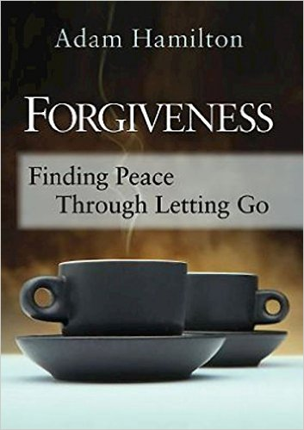 |  | How important is it that we forgive others and ourselves? United Methodist Pastor and Author Adam Hamilton compares human beings to travelers carrying backpacks full of rocks. Over time, each pebble and boulder weighs us down . . . and if we don't release our anger, it's liable to crush our spirit. Discover the benefits of "letting go" to experience grace, reconciliation, and joy!  (Includes DVD with four 10-12 min. of video per session.)
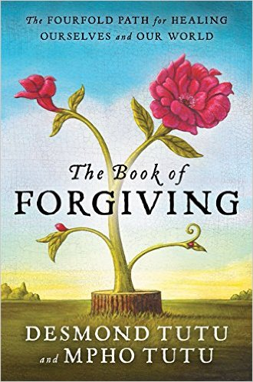 |  | The Book of Forgiving: The Fourfold Path for Healing Ourselves and the World, written by Anglican Archbishop and South African social rights activist Desmond Tutu along with his daughter and Episcopal Priest Mpho Tutu. Tutu’s consideration of a four-step process of forgiveness: Telling the Story, Naming the Hurt, Granting Forgiveness, and Renewing or Releasing the Relationship.  Book also has meditations, exercises, and prayers to guide the reader along the way. (5-6 weeks or more as desired)
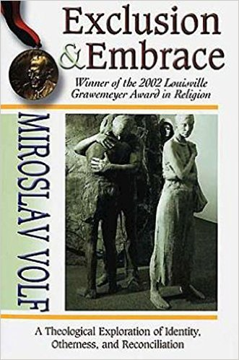 |  | A Theological Exploration of Identity, Otherness, and Reconciliation. Author Miroslav Volf is a Professor of Systematic Theology at Yale University Divinity School.  A native Croatian, he writes out of his own firsthand experience of teaching in Croatia during the war in former Yugoslavia. (5-6 weeks or more as desired) Book is the Winner of the Louisville Grawemeyer Award in Religion
Daily Devotional Option | Title |  | Author
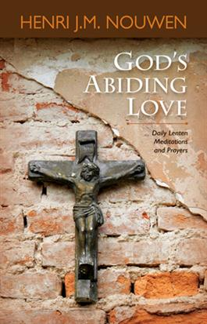 | God’s Abiding Love:  Daily Meditations and Prayers |  | Henri J.M. Nouwen, Dutch Catholic Priest, Pastor, Professor, writer, and theologian who taught at Notre Dame and Yale University, and also went on to work with mentally and physically handicapped people at the L’Arche Daybreak Community in Richmond Hill, Ontario.

